

**Using Collaborative Tools in the Classroom**

*Participant Manual*



Student Files (in course order)

Africa Report Ideas

Africa Report Outline

Africa Outline Addition

Word Table Data

Word Table Format

Africa Geography Report Draft

Asia and Africa Data

Asia and Africa Data Search

Asia and Africa Data Sort

Africa Data Subtotals

African Highways Report

Africa Continent Format

Africa Continent Adding Slides

Africa Continent Animation

Africa Continent Hyperlink

Slide 4 Congo Picture

Slide 5 Congo Mask

Lulua Mask Hyperlink

Africa Continent Weblink

Map of Eastern Africa Link

Water Quality Indicators

Africa Continent One Note Edit

Tree

Central Africa Tam Tam

Drum

Africa Continent Final

Periodic Table

Integration Project Files

Collaborative Writing Unit Plan

Newsletter Styles Lesson Plan

Population Mathematics Lesson Plan

Climate and Weather Lesson Plan

Thinking as a Poet Lesson Plan

Trademarks

Triple click, and enter registered trademarks.

Disclaimer

While Knowledge Network Solutions, Inc. is conscientious in its efforts to ensure the accuracy of this student manual, no warranty is provided regarding the effectiveness, accuracy, or suitability of the material contained in this manual.

Copyright

This student manual is copyrighted by Knowledge Network Solutions, Inc. with all rights reserved. This student manual and any relevant student files may not be reproduced in any form or by any means without the prior written permission of Knowledge Network Solutions, Inc.

Table of Contents

Setting the Stage: Introduction 5

Setting the Stage: Introduction 6

What is Project Based Learning? 6

Classroom Collaborations and Cooperative Learning as Components of Project Based Learning 9

Exploration – Discussing Project-based Learning 10

The Collaborative Project Based Unit Plan 11

Integration Project Unit Plan 12

Use of Microsoft Products for Classroom Collaboration 17

Explore: Navigating the Windows Environment 17

Explore: Using MS Office207 17

Explore: Using MS Office Live or Share Point 18

Test Your Knowledge 19

Curriculum Connections 21

Unit 1: Collaboration for Content Development and Writing 23

Collaboration on Content Development and Writing 24

Integration Project Introductory Lesson Plan 24

Office Tools to Aid Collaborative Writing 27

Explore: Prewriting with MS Office Word 2007 27

Explore: Creating a First Draft 29

Explore: Creating a Table in Word 29

Explore: Adding Data to a Word Table 31

Explore: Formatting a Word Table 33

Explore: Using Office Live Workspaces 33

Explore: Using Office Live and Office Word 2007 to Retrieve and Edit a Document 36

Explore: Creating a Final Draft and Saving as a New Version 37

Explore: Publishing a Report Using Word Templates 39

Test Your Knowledge 41

Curriculum Connections 43

Unit 2: Collaboration across the Content Areas 46

Collaboration across the Content Areas 47

Integration Project Lesson Plan 50

Exploring Databases Using MS Office Excel 2007 53

Explore: Navigating in MS Office Excel 2007 54

Explore: Using Excel Research Features 55

Explore: Sorting data 56

Explore: Filtering Data 58

Explore: Creating a Pivot Table 61

Explore: Creating Pivot Charts in Excel 61

Test Your Knowledge 63

Curriculum Connections 64

Unit 3: Collaboration on Presentations 67

Collaborations on Presentations 68

Integration Project Lesson Plan 68

Using MS Office Tools for Collaboration on Presentations 71

Explore: Setting up Your Workspace 71

Explore: Navigating MS Office Power Point 72

Explore: Adding Slides and Content 73

Explore: Adding an Audio Clip 76

Explore: Adding Animation 77

Explore: Adding Hyperlinks 78

Test Your Knowledge 81

Curriculum Connections 83

Unit 4: 21st Century Tools to Aid Collaboration 85

21st Century Tools to Aid Collaboration 86

Integration Project Lesson Plan 88

Explore: Using One Note for Collaborative Projects 90

Setting Up a Live Mesh Network 93

Explore: Navigating the Live Mesh Website 94

Explore: Accessing a Shared File on a Remote Desktop 97

Test Your Knowledge 99

Curriculum Connections 100

Unit 5: Tying It All Together 103

Tying It All Together 105

The Benefits of Project Based Learning 105

Explore: Thinking about the Benefits of Project Based Learning 106

MS Tools to Aid Project Based Learning 107

Explore: Selecting the Right Tool for the Job 107

Designing a Project Based Unit 107

Explore: Designing a Multi Disciplinary Project 109

Explore: Changing Classroom Practice 111

Appendix : Resources for Project Based Learning and Collaboration 112

Resources for Project Based Learning and Collaboration 113

Select Online Resources for Project Based Learning 113

References on Project Based Learning 114

References on Collaborative Learning 117

Bibliography 118

Setting the Stage: Introduction

Course Objectives

Describe Effective Project Based Learning Experiences

Identify the Five Design Principles of Project Based Learning

Explain the Relationships between Collaboration, Cooperative Learning, and Project Based Learning

Identify Microsoft® and MS Office 2007® Tools Available for Implementation of Project Based Learning

Setting the Stage: Introduction

Sit tight! Fasten your seat belts. It’s the 21st Century! Have you seen the new classrooms of the 21st century? There are no walls, no buildings, and no geographical limitations to accessing information. You probably already knew that, but did you know that collaborative student projects can also transcend those traditional barriers?

Microsoft® developed the tools. You can facilitate the projects!

What is Project Based Learning?

While “doing projects” is not a new concept in education, Project Based Learning (PBL) as a unique instructional methodology has emerged in only the past 30 years. With generally less structure than traditional teacher-led activities, PBL is known for its emphasis on student organization, time management, collaboration (often across disciplines), and construction of products (artifacts) to represent what is learned.

A generally accepted definition for Project Based Learning does not exist, but experts do agree that PB is flexible and fits within a wide range of settings. Project implementation can range from a single subject area to across disciplines, from one classroom to broad community involvement, from students in a single grade level to adults outside the school, and any combination of these.

**Project Based Learning for 21st Century Skills**

Project Based Learning is one way for students to develop 21st century skills, those skills that business leaders and policymakers identify as crucial for a service-oriented, entrepreneurial, and global workplace:

* Higher order and critical thinking skills for problem solving.
* Communication in a variety of modes.
* Use of technologies to complete tasks.
* Ability to analyze, synthesize, and create. (Sawchuk, 2009)

Project Based Learning aids the development of 21st century skills by supporting multiple learning styles and intelligences, providing opportunities for cross-curricular connections, and addressing more than one standard within the framework of a single project. Students are also more likely to remember concepts because they engage in project management and investigate topics using multiple strategies. Your students will learn to apply skills and concepts rather than just memorizing them for a test (Stearns & Shay, 2008).

**Elements of a Good Project Based Learning Experience**

More important than a “one size fits all” definition for PBL is a description of what elements provide a good Project Based Learning experience for your students:

* Students are at the center of the learning process as recognition of their inherent desire to learn, their ability to do important work, and their need to be taken seriously.
* Students engage with the central concepts and principles of a discipline. The project work is central rather than incidental to the curriculum.
* Students investigate provocative issues or questions that lead them to in-depth exploration of real-world, important topics.
* Essential tools and skills, including technology, facilitate learning, self-management, and project management.
* Specific products that solve problems, explain dilemmas, or present information are generated through investigation, research, or reasoning.
* Projects yield multiple products that permit frequent feedback and consistent opportunities for students to learn from experience.
* Performance-based assessments communicate high expectations, present rigorous challenges, and require a range of skills and knowledge.
* Students collaborate in some form, either through small groups, student-led presentations, or whole-class evaluations of project results. (Markum, Mergendoller, Larmer, & Ravitz, 2003)

The body of research on Project Based Learning is growing and supports its use to cut absenteeism, increase motivation, and improve standardized test scores (Edutopia, 2001).

**The Principles of Design in Project Based Learning**

Planning for PBL is based on five dynamic principles, illustrated in Figure 1 below and briefly described in the following narrative.

**Design Principle #2:**

**Develop the**

**Driving Question**

**Design Principle #5:**

**Manage the**

**Process**

**Design Principle #1:**

**Begin with the**

**End in Mind**

**Design Principle #4:**

**Map the**

**Process**

**Design Principle #3:**

**Plan the**

**Assessment**

Figure 1. Design Principles of Project Based Learning

Design Principle #1: Begin with the End in Mind

Conceptualizing the project by its goal helps students understand the rationale and meaning behind what they are asked to do. They will retain more information, be more motivated to participate, and will be able to apply their knowledge more skillfully. Some examples of end goals you might identify include

* To create individual investment portfolios, with accompanying business plans and product prototype.
* To educate the public about point source pollution.
* To understand the underlying causes of the Civil War. (Moursund, 2003)

Design Principle #2: Develop the Driving Question

A good driving question addresses authentic concerns and focuses on the application of content within the real world. Good questions require students to draw upon content and personal experiences, lead to other questions posed by students, and are deliberately thought-provoking, counterintuitive, and sometimes controversial (Greece Central School District).

Design Principle #3: Plan the Assessment

Project assessments should come in multiple forms, with activities that are diverse enough to include all students, yet specific enough to provide relevant and meaningful. Think about the process of triangulation:

* Multiple assessors. Students, peers, the teacher, and mentors.
* Multiple units of assessment. Individual students, groups, the whole class.
* Multiple formats. Written work (formal assignments and informal journal entries), observations (of group activities and individual work), presentations, informal discussions and questions, project designs, and the final media product (San Mateo Board of Education, 2001).

Expect your students to master the core content, conventions, and vocabulary of a topic.

Design Principle #4: Map the Project

Similar to a lesson plan, the project map helps you identify skills students need to perform, develop a timeline, and identify resources necessary to project implementation.

Design Principle #5: Manage the Process

The teacher as facilitator must be able to guide students through ®the learning process as well as keep the project focused and moving forward. You may have to learn or hone these skills as part of your own introduction to PBL.

Source, Figure 1 and Primary Source, Design Principle Information: (Buck Institute for Education and Boise State University, 2003)

As noted, one of the elements of effective PBL experiences is **collaboration.** Collaboration is not just among students, but also is between students and the teacher, and conceivably between students and other community members (San Mateo Board of Education, 2001). The following section describes collaboration and one of its forms, cooperative learning, in more detail as components of Project Based Learning.

Classroom Collaborations and Cooperative Learning as Components of Project Based Learning

Collaborative procedures of the past by necessity involved team members working with copies of printed documents and within the limitations of face-to-face meetings and telephone calls. In today’s world, collaborations are possible using a variety of Microsoft products that enable individuals and groups to maximize the use of their time and paper resources. Scheduling issues don’t have to remain a barrier to cross-departmental or interdisciplinary work!

According to *MSN Encarta Online Dictionary*, collaboration is defined as “the act of working together with one or more people in order to achieve something.” To promote working together and achieving common goals, Microsoft Office applications enable implementation of projects that provide students with

* Anytime access to the most current version.
* The ability to use programs and applications they already know or are easy to learn.
* The ability to retain all versionsin case of the need to add content back in.
* Automatic saving, just in case they forget an important step.
* The ability for the teacher to identify contributions of individual team members.

Participating in collaborative group projects is an effective way for your students to achieve academic, technology, and social learning goals.

Cooperative Learning

Cooperative learning is a collaborative instructional strategy that is one key to the success of project based learning. In true cooperative learning situations, students work together to achieve shared learning goals (Johnson & Johnson, 1999) and each student achieves his/her goals only if other students achieve theirs (Deutsch, 1962). A 2000 study conducted by Johnson, Johnson and Stanne found that cooperative learning, when implemented properly, yields a significantly positive impact on student achievement when compared with both individualized and competitive learning strategies. (Johnson, Johnson, & Stanne, 2000)

There is a great difference in simply having students work together in a group setting and having a structured group that requires cooperation and collaboration. Johnson and Johnson (1994) identified five elements of cooperative learning that clearly distinguish it from a non-cooperative group process:

* Positive interdependence. Students know they must individually learn assigned material, but each also understands that he/she helps ensure that all team members learn the material, as well.
* Face-to-face interactions. Individual team members encourage and facilitate each other's efforts to achieve, complete tasks, and produce in order to reach the group's goals.
* Individual Accountability and Responsibility. Individual members’ performance is assessed, reviewed by the group, and assistance is provided by group if necessary to aid improvement.
* Interpersonal and small group skills. Students get to know and trust one another, learn to communicate effectively, accept and support each other, and resolve conflicts constructively.
* Group processing. Team members continuously assess work progress, chosen methods to complete assignments, and revise as needed. (Source: <http://www.co-operation.org/pages/overviewpaper.html>).

Cooperative learning and its various forms fit well with the intent and purpose of project based learning. Unit 1 of this manual introduces a cooperative project based learning activity designed to foster the five elements of cooperative learning.

Other Major Elements of Project Based Learning

There are several other major elements of PBL that you will want to include as you design your PBL unit. These include the following beyond the essential question: collaboration; communication; critical thinking; inquiry learning; synthesis. These elements are addressed individually during the four Microsoft EXPAND modules.

Exploration – Discussing Project-based Learning

* List some projects that you currently have your students complete.
* List the skills that the students master by completing one of the projects.
* Do any of the projects involve opportunities for collaborative work?
* Are any of the projects long term projects?
* Do any of the projects address essential questions or introduce problems to be solved?
* Are the projects student-centered?
* Do any of the projects involve real-world issues or skills?
* How are the projects assessed?
* How would adding a technology component help the students better complete their projects? Better master the objectives?

The Collaborative Project Based Unit Plan

How can you motivate your students to write? One of the best ways is to publish their writing.

A class project to create a newsletter helps students develop language skills such as building vocabulary, improving written and oral expression, and learning how to revise their own written work. Students can also learn the value of teamwork when the work is done collaboratively. As an educator, you can empower your students through writing experiences that provide a sense of ownership and pride. Students from varied backgrounds and ability levels can learn to work cooperatively and find common ground for discussions.

In the following unit, Mr. Jonathan Kidman’s Language Arts students collaborate to produce a report on the continent of Africa, to be followed by their participation in an interdisciplinary “Africa Experience Project.” The interdisciplinary project involves them in two major ways

* Editing documents including PowerPoint presentations.
* Writing a newsletter that highlights the community open house which will showcase the project results.

Writing activities include brainstorming, drafting, revising, editing, and publishing.

Integration Project Unit Plan

| KNS  For Standards-based, Student-centered, Technology-rich Learning | Teacher: | Jonathan Kidman |
| --- | --- | --- |
| School/District: | Homestead Middle School |
| Subject Area(s) Addressed: | Writing |
| Grade Level(s)/Course: | 6th – 8th Grade Language Arts |
| Date Submitted: | July 1, 2009 |
| Unit Duration: | 10 50-minute periods |

|  |  |  |
| --- | --- | --- |
| Unit Title | Creating an Online Report | |
| General Unit  Outcomes | The Language Arts students have just completed a unit on writing preparation for reporting data, events, and basic interview techniques using a protocol. Based on their previous experiences with library and Internet research, they have designed a data collection sheet and an interview protocol. They will collect data from a variety of sources to write a report on the continent of Africa as part of their school-wide online newspaper.   1. Students work collaboratively to plan, design, create, write, and publish an online report on the continent of Africa. 2. Students use a word processing application and many of its formatting features, styles, and editing tools to complete their writing assignments throughout the writing process (brainstorming, prewriting, drafting, revising, editing, and publishing). 3. Students will use the Internet, magazines and newspapers, library resources, community resources, and school resources to complete the project. | |
| **Academic Standards Addressed** | Standards for the English Language Arts: NCTE and IRA (http://www.ncte.org/about/over/standards/110846.htm)   1. Students apply a wide range of strategies to comprehend, interpret, evaluate, and appreciate texts. They draw on their prior experience, their interactions with other readers and writers, their knowledge of word meaning and of other texts, their word identification strategies, and their understanding of textual features (e.g., sound-letter correspondence, sentence structure, context, graphics). 2. Students adjust their use of spoken, written, and visual language (e.g., conventions, style, vocabulary) to communicate effectively with a variety of audiences and for different purposes. 3. Students employ a wide range of strategies as they write and use different writing process elements appropriately to communicate with different audiences for a variety of purposes. 4. Students apply knowledge of language structure, language conventions (e.g., spelling and punctuation), media techniques, figurative language, and genre to create, critique, and discuss print and non-print texts. 5. Students develop an understanding of and respect for diversity in language use, patterns, and dialects across cultures, ethnic groups, geographic regions, and social roles. 6. Students whose first language is not English make use of their first language to develop competency in the English language arts and to develop understanding of content across the curriculum. 7. Students participate as knowledgeable, reflective, creative, and critical members of a variety of literacy communities. 8. Students use spoken, written, and visual language to accomplish their own purposes (e.g., for learning, enjoyment, persuasion, and the exchange of information). | |
| **Technology Standards Addressed** | Technology Foundation Standards for Students (Source: NETS, <http://www.ISTE.org>)   1. Creativity and Innovation.   Students demonstrate creative thinking, construct knowledge, and develop innovative products and processes using technology. Students:  a. apply existing knowledge to generate new ideas, products, or processes.  b. create original works as a means of personal or group expression.  **2. Communication and Collaboration**  Students use digital media and environments to communicate and work collaboratively, including at a distance, to support individual learning and contribute to the learning of others. Students:   1. interact, collaborate, and publish with peers, experts, or others employing a variety of digital environments and media.   b. communicate information and ideas effectively to multiple audiences using a variety of media and formats.  d. contribute to project teams to produce original works or solve problems.  **3. Research and Information Fluency**  Students apply digital tools to gather, evaluate, and use information. Students:   1. plan strategies to guide inquiry. 2. locate, organize, analyze, evaluate, synthesize, and ethically use information from a variety of sources and media.   c. evaluate and select information sources and digital tools based on the appropriateness to specific tasks.  d. process data and report results.  **4. Critical Thinking, Problem Solving, and Decision Making**  Students use critical thinking skills to plan and conduct research, manage projects, solve problems, and make informed decisions using appropriate digital tools and resources. Students:  b. plan and manage activities to develop a solution or complete a project.  c. collect and analyze data to identify solutions and/or make informed decisions.  **5. Digital Citizenship**  Students understand human, cultural, and societal issues related to technology and practice legal and ethical behavior. Students:  a. advocate and practice safe, legal, and responsible use of information and technology.  b. exhibit a positive attitude toward using technology that supports collaboration, learning, and productivity.  c. demonstrate personal responsibility for lifelong learning.  d. exhibit leadership for digital citizenship.  **6**. **Technology Operations and Concepts**  Students demonstrate a sound understanding of technology concepts, systems, and operations. Students:  a. understand and use technology systems.  b. select and use applications effectively and productively.  d. transfer current knowledge to learning of new technologies. | |
| **Teacher-Led Activities** | Sixth, 7th, and 8th grade students in all disciplines will be participating in an interdisciplinary project, Experience Africa, that will culminate in a community-wide open house to highlight project activities and artifacts. The Language Arts students will create reports and a newsletter as part of their participation, which also includes editing of PowerPoint presentations and writing poems. This preliminary unit engages student teams in report writing focused on the continent of Africa.   1. Divide students into 3-4 person teams and provide each student with a project instruction sheet. Explain to students how this unit will be used to prepare for the upcoming Africa Experience unit. 2. Show National Geographic video on the continent of Africa and lead discussion. 3. Lead students through initial brainstorming activities and then direct students to complete the activities. Students may use tablet PCs to record collected data. Teams should be given enough time to brainstorm about the assigned topics for their respective assignments and to assign tasks for the writing assignment. 4. Provide direct instruction on MS Office Word table creation and use of report templates. 5. Provide direct instruction on use of MS Office Live workspaces. 6. Monitor and provide feedback on revised drafts of reports. 7. Provide individual group and whole group feedback on completed reports. | |
| **Student-Centered  Activities** | Students have had instruction in the concepts of data and data collection. They have not used data tables for the collection and sorting of non-scientific data. They have also participated in brainstorming and prewriting activities.  DAY 1: Introductory Lesson: Introduction to Africa   * Students view Africa video (Animals of the African savanna) to introduce them to the continent, taking notes. * Following video, students engage in brainstorming session, with several taking turns writing information on Post It Easel Pads, Tablet PC One Note, or board. * Groups identify all brainstormed ideas that would be good to include in a report on the African continent. Others not mentioned in the video should be added at this time (since the video focused primarily on animals). * Student groups organize based on teacher instructions. Ideally, groups should have 3-4 students, but this is flexible. * Groups review project instruction sheets and discuss among themselves. Students review instruction sheets with teacher. * Each group works independently to categorize brainstormed ideas into major categories—e.g., History, Geography, Natural Resources.   DAY 2:  Brainstorming Content   * Using the broad topic areas from the previous day, large group engages in a discussion to identify the 5-6 content areas to include in the report. * The large group will then use individual group sorting of brainstormed ideas to place the ideas into content area categories. * Additional items can be added. Large group should finalize report content and make team assignments for sections. * Using instruction provided by teacher, individual teams set up Office Live workspace project site. * Individual teams develop work plan and assign tasks based on those outlined in the instruction sheets.   DAY 3:  Initial research activities   * Individual teams develop or review work plan and assigned tasks. Students discuss plan and identify needed resources. * Based on team and individual assignments, teams brainstorm to identify key questions to answer as part of their research activities. * Students develop outline of report based on their assignment and key questions. * Teams create MS Word data table for data collection activities.   DAY 4:  Research activities   * Students conduct Internet or library research. Notes are kept on a desktop, laptop, or mini-note.   DAY 5:  Research activities   * Students conduct Internet or library research. Notes are kept on a desktop, laptop, or mini-note.   DAY 6:  Additional prewriting – adding to the outline   * Team members collaborate to add additional information to the outline based on their research notes. * Document is saved to MS Office Live project workspace.   DAY 7:  Writing a first draft   * Team members individually write a first draft of their assigned report sections. * Document is saved to MS Office Live project workspace.   DAY 8:  Revising and rewriting   * Team members access others’ documents and make suggestions for revisions. * Upon receiving revisions, individuals rewrite their assigned report sections.   DAY 9:  Writing a final draft   * Individual team members rewrite assigned report sections. * Team members collaborate to combine sections and create final draft of team’s assigned report section.   DAY 10:  Publishing the document   * The Continent of Africa Report is published collaboratively using an MS Word template. | |
| **Resources Needed** | Content resources (books, articles, speakers, handouts, materials, etc.) | Software/Web Resources (CD-ROMs,URLs, etc.) |
| * Individual lesson plans * Project Direction Sheets * Samples of data collection sheets | * MS Office Word 2007**®** * Office Live**®** workspace for project site |
| Hardware (computers, TV, DVD, etc.) | Other media, video, satellite, etc. |
| * Mini-Notes or Tablet PCs, if available, minimum one per group (6) * Computer lab with multimedia computers and Internet connectivity * Computer with projection device and viewing screen | * Introductory video on Africa   http://videos.howstuffworks.com/hsw/20552-animals-of-the-african-plains-a-photo-safari-video.htm# |
| **Student Assessment Strategy** | * Conduct ongoing formative assessments during the course of the unit and individual lessons. Monitor individual student contributions to each assignment. * Summative assessment of products * Group draft reports * Team/small group final reports, using rubric * Whole group report | |

Use of Microsoft Products for Classroom Collaboration

Microsoft has a variety of tools to aid teachers in the planning and implementation of collaborative projects. In this and the following units, several PC based, two web based, and one server based application will be introduced and explored.

Explore: Navigating the Windows Environment

Windows Vista and Vista Ultimate

Windows Vista**®** and Vista Ultimate**®** are the perfect choices for both personal and work use. Special features of Vista Ultimate include enhanced search features, improved visualization capabilities, simplified maintenance, and advanced security features.

Explore: Using MS Office207

MS Office Word 2007

MS Office Word 2007**®** is a word processing program that alleviates the sometimes daunting tasks of hand-writing, revising, and rewriting. Word provides tools such as **cut and paste** to move text with ease, **delete** to remove text with the push of a button, **formatting tools and images** to enhance the appearance of a document, and **spelling and grammar checks**. The **Track Changes** feature of Word enables multiple individuals to edit and contribute to one document. Another useful feature is the ability to view two separate documents **side-by-side** or different sections of the same document horizontally. MS Office Online**®** provides users with templates for many types of documents including to-do-lists, calendars, project organizers, greeting cards, certificates, resumes, and many others.

MS Office Excel 2007

MS Office Excel 2007**®** is a robust tool you can use to create and format spreadsheets or analyze and share information in a database format. You can use Excel to easily **create and use professional-looking charts**, which can interface with other Office products. Large amounts of data can be stored and manipulated with Excel through its 1 million rows by 16,000 columns, and built-in cell and table styles allow **custom formatting**. Excel also contains basic analysis tools such as **sorting**, **filtering**, and **reorientation of data** using pivot charts.

MS Office PowerPoint 2007

MS Office PowerPoint 2007**®** enables users to quickly **create**, **share,** and **manage** dynamic presentations. Use one of the stored or online slide templates, or create your own with the easy-to-use **formatting options**. Once created, presentations can be stored as individual slides on a site supported by MS Share Point**®** and their content used at a later time to build new presentations. Power Point contains a **library of document themes** to enable users to change the look and feel of a presentation with just a click!

MS Office OneNote 2007

MS Office OneNote 2007**®** provides you a place to gather all your notes and information. It functions as a **digital 3-ring binder**. OneNote has a powerful search feature and easily-used, shared notebooks for more efficient **team and project management**.

OneNote offers flexibility not available with conventional paper-based systems (e.g., word processors, e-mail, or others), enabling the user to **gather and organize** text, pictures, digital handwriting, audio and video recordings, and more, in a digital notebook. OneNote 2007 can increase your productivity and reduce the time you spend searching for information by keeping **everything in one place** and at your fingertips.

Explore: Using MS Office Live or Share Point

MS Office Live

Creation of a **shared workspace** using Microsoft Office Live**®** makes it easy to organize, manage, and share documents, notes, spreadsheets, presentations, contacts, to-do lists, and more. A project workspace can be used by students to collect and share key documents for their assigned tasks. Documents can be revised and then shared as separate versions. Other features make Office Live Workspace ideal for teamwork—such as e-mail notifications of activities, both locked and shared workspaces, project calendar and other useful templates, and ability to generate online comments.

MS Office Share Point

Microsoft Office SharePoint 2007**®** is a **server-based program** that is part of the Microsoft Office 2007® system. Use of Share Point facilitates collaboration through its many content management features. Teams can **work effectively** to create and publish documents, develop and maintain task lists, control workflow, and use wikis and blogs to share information. Individual team members can also create a personalized portal to share information with others. Office SharePoint is designed to work efficiently with other products in the 2007 Office system.

Test Your Knowledge

The tasks below were addressed in this unit. Be sure you understand the terms used and are able to complete the tasks listed.

Review Me – Identifying Application Platforms

1. List two Microsoft PC based application programs that you will explore.­
2. ____________________________________________________________________
3. Name a Microsoft web based application.___________________________________
4. Which PC based application enables users to share documents?__________________

Review Me – Selecting the Correct Application

1. Which MS Office application is best for sorting data? _________________________
2. Which MS Office application functions as a digital notebook? __________________
3. Which application would be used for online organization?______________________

Review Me – Understanding Project Based Learning

1. Create a working definition of project based learning. _________________________
2. ____________________________________________________________________
3. List two ways you think technology aids to the success of project based learning.
4. _____________________________________________________________________
5. _____________________________________________________________________
6. How do you think project based learning helps those students who have learning difficulties?
7. _____________________________________________________________________
8. _____________________________________________________________________

Curriculum Connections

Students use computers in the classroom as a tool for both productivity and learning. Integrating computer skills with the academic curriculum motivates and engages students, and prepares them for the technology age.

Below are a few ideas which can be used to integrate the skills covered in this unit into the academic curriculum.

Idea 1 – Math Projects

* Students investigate the mathematics involved in the construction of a kaleidoscope and make a model.
* How are math and statistics used in sports? Students track a team or league during a season, using a database to record, sort, and chart the data.
* Students use the Internet to study the history and use of the abacus. They build a model and develop a presentation using PowerPoint.

Idea 2 – Science Projects

* Students form teams to investigate and design a human settlement on Mars. Findings are presented in the form of a digital notebook.
* Student “delegates” to a world environmental congress gather and present data, online, on the global impacts of deforestation of the Rain Forest and make recommendations.
* Students examine real-world data on smoking and cancer and create an age-appropriate brochure for distribution to the middle school.

Idea 3 – Interdisciplinary Projects

* Math, science and social studies students complete a Chesapeake Bay Project (or any other body of water) to examine its history, ecosystem, and economic contributions to surrounding states.
* Science, language arts, and art students create a wildlife field guide of their local area.
* Science, language arts, math, social studies, and art students investigate popcorn. They explore why it pops, create a limerick about popping corn, use a database to record pre- and post- popping weight and volume, create charts and graphs, study popcorn as part of native American history, and create a picture using popcorn as the media.

Use the space below to write down additional curriculum connections ideas:

|  |
| --- |
|  |
|  |
|  |
|  |
|  |
|  |
|  |
|  |
|  |
|  |
|  |
|  |
|  |
|  |
|  |
|  |
|  |
|  |
|  |
|  |

Unit 1: Collaboration for Content Development and Writing

Unit Objectives

Navigate Windows Vista to open MS Office and Web applications.

Create collaborative writing products using MS Office 2007 applications.

Develop MS Office Live workspaces to share and edit documents.

Collaboration on Content Development and Writing

The 6th - 8th grade Language Arts students have just completed units on writing preparation for reporting data, events, and basic interview techniques using a protocol. They plan to create an online newsletter following an open house presentation of the school-wide Africa Experience project, but in preparation for that activity they will first be gathering data and writing brief reports on the African continent.

Review the unit plan again that begins on page 12. Throughout Unit 1, each lesson will refer to the unit plan and it will guide you through the use of MS Office Word 2007 and other MS Office tools as you work though the writing process.

Students previously designed a data collection sheet and an interview protocol based on their experiences conducting library and Internet research. This has prepared them well for the unit on writing a report and for a later unit on newsletter writing. Examine the following lesson for this unit:

Integration Project Introductory Lesson Plan

| KNS  For Standards-based, Student-centered, Technology-rich Learning | Teacher: | Jonathan Kidman |
| --- | --- | --- |
| School/District: | Homestead Middle School |
| Subject Area(s) Addressed: | Writing |
| Grade Level(s)/Course: | 8th Grade Language Arts |
| Date Submitted: | July 1 |
| Lesson Duration: | 1 90-minute lab period |

|  |  |  |
| --- | --- | --- |
| Unit Title | Africa Experience | |
| Lesson Title | Report Writing from a Datasheet | |
| General Lesson  Outcomes | Student groups have been learning about the data collection process in all of their classes. In Language Arts, students collected data from library and Internet sources and are now ready to compile the data in a table. Groups will subsequently write and publish an online report to highlight the continent of Africa and showcase the upcoming Africa Experience project. This lesson focuses on organizing the data and the prewriting experience.  Following completion of this lesson, students will   1. Brainstorm ideas for report. 2. Create an outline for report contents. 3. Design a data collection sheet based on desired information for report. | |
| **Academic Standards Addressed** | Standards for the English Language Arts: NCTE and IRA (http://www.ncte.org/about/over/standards/110846.htm)  3. Students apply a wide range of strategies to comprehend, interpret, evaluate, and appreciate texts. They draw on their prior experience, their interactions with other readers and writers, their knowledge of word meaning and of other texts, their word identification strategies, and their understanding of textual features (e.g., sound-letter correspondence, sentence structure, context, graphics).  4. Students adjust their use of spoken, written, and visual language (e.g., conventions, style, vocabulary) to communicate effectively with a variety of audiences and for different purposes.  11. Students participate as knowledgeable, reflective, creative, and critical members of a variety of literacy communities.  12. Students use spoken, written, and visual language to accomplish their own purposes (e.g., for learning, enjoyment, persuasion, and the exchange of information). | |
| **Technology Standards Addressed** | Technology Standards (NETS – http://www.iste.org)   1. Creativity and Innovation.   Students demonstrate creative thinking, construct knowledge, and develop innovative products and processes using technology. Students:  a. apply existing knowledge to generate new ideas, products, or processes.  b. create original works as a means of personal or group expression.  2. Communication and Collaboration  Students use digital media and environments to communicate and work collaboratively, including at a distance, to support individual learning and contribute to the learning of others. Students:  a. interact, collaborate, and publish with peers, experts, or others employing a variety of digital environments and media.  b. communicate information and ideas effectively to multiple audiences using a variety of media and formats.  d. contribute to project teams to produce original works or solve problems.  3. Research and Information Fluency  Students apply digital tools to gather, evaluate, and use information. Students:  plan strategies to guide inquiry.  a. locate, organize, analyze, evaluate, synthesize, and ethically use information from a variety of sources and media.  c. evaluate and select information sources and digital tools based on the appropriateness to specific tasks.  d. process data and report results.  4. Critical Thinking, Problem Solving, and Decision Making  Students use critical thinking skills to plan and conduct research, manage projects, solve problems, and make informed decisions using appropriate digital tools and resources. Students:  b. plan and manage activities to develop a solution or complete a project.  c. collect and analyze data to identify solutions and/or make informed decisions.  5. Digital Citizenship  Students understand human, cultural, and societal issues related to technology and practice legal and ethical behavior. Students:  a. advocate and practice safe, legal, and responsible use of information and technology.  b. exhibit a positive attitude toward using technology that supports collaboration, learning, and productivity.  c. demonstrate personal responsibility for lifelong learning.  d. exhibit leadership for digital citizenship.  6. Technology Operations and Concepts  Students demonstrate a sound understanding of technology concepts, systems, and operations. Students:  a. understand and use technology systems.  b. select and use applications effectively and productively.  d. transfer current knowledge to learning of new technologies. | |
| **Teacher-Led Activities** | 1. Review previous lesson on design of data collection sheet. 2. Show various examples of data collection sheets from class, other classes, online, lab books borrowed from science teacher, etc. Ask students to volunteer their likes and dislikes of what they observe. 3. Using MS OfficeWord2007 to review the techniques for table design. 4. Facilitate discussion to determine style and color choice(s) for the data table. All groups will use the same format. | |
| **Student-Centered  Activities** | 1. Students will review samples of data collection sheets that have been provided by the teacher. 2. Students will provide initial input on data table format and select style, color choice(s) for use by all groups. 3. Students brainstorm to develop content for report. The whole group discusses the content ideas to agree on what should be in report. Sections of the report are assigned to groups. 4. Student groups use MS Word to develop a content outline for their section of the report. 5. Student groups use MS Word to design their individual data collection sheets. They begin to conduct library and Internet research to find and record the data. | |
| **Resources Needed** | Content resources (books, articles, speakers, handouts, materials, etc.) | Software/Web Resources (CD-ROMs,URLs, etc.) |
| * Sample data collection sheets. | * MS Office Word 2007 * Various online reports and data collection sheets for review * *MSN Encarta Online reference materials* |
| Hardware (computers, TV, DVD, etc.) | Other media, video, satellite, etc. |
| * Mobile cart with lap tops for student use at work tables. |  |
| **Student Assessment Strategy** | * Formative assessment during group work processes. * Items on unit quiz related to writing conventions for report writing from datasheets. | |

Office Tools to Aid Collaborative Writing

If your students only use word processing for typing final drafts, you may be surprised how much efficiency (and fun for the students) is gained by having them complete all writing steps on the computer. They don't have to create clean or fully developed text the first time, and can use MS Office Word 2007 or One Note to jot down ideas as they come--without looking up spelling or other details!

A word processor can be used to just make a note or for much more sophisticated formatting and drawing. Word 2007 also has features (such as text highlighting) that enable the writer to mark areas that need completion or the place in the text to return. Students who have access to Mini-note or Tablet PCs can hand-write, highlight, or mark these areas in some other way. Students can create a full draft quickly and then return at any time to revise and strengthen it. A web-based project workspace on Office Live allows team members to store draft documents to be downloaded, edited, and resaved as a separate version by their peers.

Refer to the report writing project. In the introductory lesson students learned that reports are sometimes written to present data, which can be compiled from a variety of sources:

* Original data collected as part of a single experiment or interview process.
* Meta analysis or synthesis of original data from previously conducted research.
* Library and literature search.

Students have also brainstormed previously to list ideas and generate outlines from their lists.

In the second lesson, the whole class will **brainstorm** to create a list of content about the African continent to include in their online reports. Individual groups will be assigned unique content areas to cover following this period of whole group discussion. The student groups will then use Word to outline their assigned sections and use this information to develop a data collection table. The groups will use the tables they have created to collect and sort data for their reports. These introductory lessons help students begin to think and get the “gears turning” in preparation for their report writing and newsletter assignment later in the project.

Now that prewriting has been modeled in the class brainstorm session, students continue with creation of outlines to guide the writing of their reports and the creation of data tables. You will use the tools of Word and other Office products in the following lesson while you create an outline, review strategies for saving and organizing documents, design a table, and use task panes for a variety of Word tools.

Explore: Prewriting with MS Office Word 2007

Your group has been assigned the section of the online report that deals with African continent geography. You will create an outline for this section of the report and continue to work on developing the report by creating a first draft.

1. If necessary, open MS Office Word 2007.

Windows Vista

1. Click StartMenuButton and open Microsoft Office Word 2007. If MS Word does not show up on the Start menu, click All Programs, Microsoft Office, and select Office Word 2007 or just type Word into the **Search** box.
2. Open the document titled *Africa Report Ideas.docx*. This document contains the brainstormed report ideas developed by the whole class.
3. Open the document titled *Africa Report Outline.docx*. This document contains the general content outline for the full report, also developed by the entire class, and how assignments were made by group.
4. In the **View** tab, **Window** section, click Arrange All. You should see both the report ideas and content outline for the report arranged horizontally on the screen.
5. In the **View** tab, **Window** section, click View Side by Side. Notice that both documents are now arranged vertically on the screen. Move the cursor to the right side scroll bar of one document and move. Word 2007 defaults to synchronous scrolling, but you can remove this feature if necessary.

**Note:** You can toggle between horizontal and vertical document arrangement by clicking Reset Window Position in the **View** tab, **Window** section.

1. If necessary, go back to the horizontal arrangement of documents. Using the bottom document, place the cursor on the ribbon, press the right mouse button, and select Minimize the Ribbon from the drop down menu.

**Note**: You may also adjust the height of either or both documents by moving the cursor to the edge of the document until you see , pressing the left mouse button and dragging the document.

1. Review the outline using the brainstormed ideas. Place the rest of the brainstormed ideas under the report categories (examples are provided). The new outline will contain the content information that will be used in your article.
2. To add Animals to the Geography outline category, place the cursor behind Regions and type Enter. Word will automatically create a new numbered line. Type Animals.
3. Save the outline you have created as *[Your First Name] Report Outline.docx*. Close both documents.

Explore: Creating a First Draft

You and your team have already prioritized what to include through a brainstorming exercise and by writing an outline. Since your section of the report will be limited to about two pages (800-1,000 words), including graphics and highlights, you will gain valuable practice in synthesizing and condensing information.

1. Open the document *Africa Outline Addition.docx*. You have started the first step in writing your report by creating a good outline of the content to include.
2. Your group has been assigned section II of the report, Geography. You decide that you need to create three “working documents.”

* An expanded outline with additional information of what to include in each of the content areas.
* A map and list of all the countries in each region of Africa.
* A data collection table.

1. The group decided to add the list of what to include in the data table to the outline. In the space below Information for data table:, add the following items to the list:

* Climate for each country
* Major rivers for each country
* Major lakes for each country

1. Save as *[Your Name] Africa Outline Addition.docx.* Leave open.

Explore: Creating a Table in Word

Your expanded outline is completed and a list developed to create your data collection table. Word contains tools that make the creation of a table easy, either directly in a document or to copy and paste from another document.

1. If necessary, open the document *[Your] Africa Outline Addition.* The group realizes that it has neglected to include information about landforms or land type in its outline. Type Land Characteristics to your list of items to include in the data table.
2. Count the number of items in the list. _____________________________
3. Place the cursor several lines below the data table items. In the **Insert** tab, **Tables** section, click the arrow below the **Table** icon. Select Insert Table.
4. There are 53 countries in Africa in 11 regions. Create a table with 9 columns and 12 rows, 1 row for each region plus the heading. If you need to add more columns or rows, Word tools allow you to do so very easily.
5. Notice that the columns are very narrow. If you create a table using landscape design (paper layout), the columns will be wider. Delete the table by clicking the back arrow in the Quick Access Toolbar (See below.)

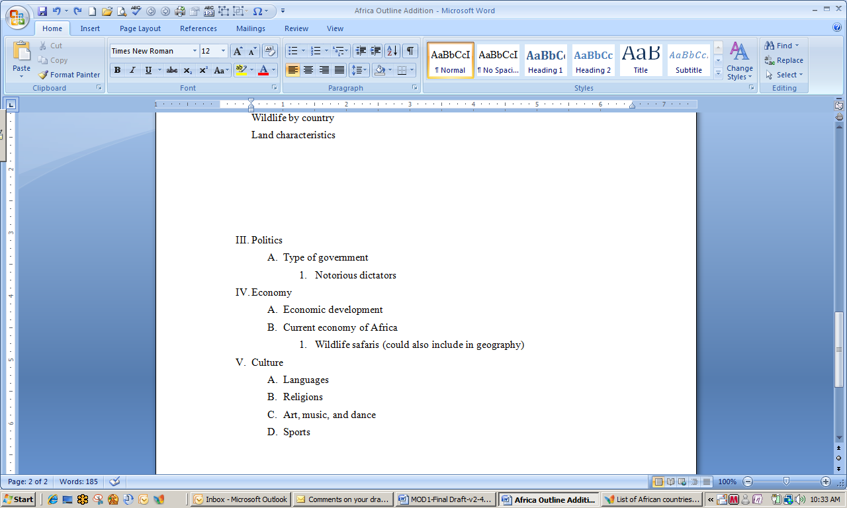

Quick Access Tool Bar

1. Click the Office button, select New, and then Blank document. Click Create.
2. In the **Page Layout** tab, **Page Setup** section, click Orientation. Select Landscape. The document will now be shown in the Landscape orientation.
3. Create a table with 9 columns and 66 rows. Note that the columns are still quite narrow. Your group decides to reduce the number of columns by collapsing some of the column data into five similar categories: Regions and Countries, Major Rivers and Lakes, Animals and Wildlife, Plants, Land Characteristics.
4. Open the Layout tab. Move the cursor above the first column until appears. Left click and drag to highlight the first four columns.
5. Go to the **Rows & Columns** section and click the arrow below **Delete**. Select Delete Columns.
6. Go to the **Cell Size** section and click the arrow below **Auto Fit**. Select Auto Fit Window. You now have five columns that are wide enough to hold and display your data.
7. Save the document as *[Your Name] Word Table.* Close.

Explore: Adding Data to a Word Table

The team is happy with its decisions about what data to collect and how to organize it. You are now ready to add data to the table and sort it for easier use.

1. Open the document *Word Table Data.* Type Animals and Wildlife in the fourth column heading. Type Plants in the 5th column heading.
2. Note that you still need a column for Land Characteristics data. Highlight the last column (Plants). Open the **Layout** ribbon. Go to the **Rows & Columns** section and click Insert Right.
3. Type Land Characteristics in the column heading. Make sure you are still have the **Layout** ribbon open. Place the cursor anywhere in the table and type Ctrl A to highlight the entire table. Auto Fit first to contents and then to window.
4. The only country in the Central Region of Africa is the Congo. Type Congo in the appropriate place.
5. The Eastern Region of Africa contains six countries: Rawanda, Burundi, Uganda, Kenya, Tanzania, and Sychelles. You have to add rows to the table in order to insert these data.
6. Highlight the third row of the table (Eastern Region data) by placing the cursor to the left of the row until you see an arrow. Left click. In the **Layout** tab, **Rows & Columns** section, click Insert Below five times.
7. Type the countries listed in #5 above into the appropriate table cell.

Sorting Data in a Word Table

You can easily sort the Eastern Region countries into alphabetical order.

1. Highlight the six Eastern Region countries by placing the cursor on the first one. Left click and then drag to the sixth country.
2. In the **Layout** tab, **Data** section, click Sort. The **Sort** dialog box will appear as in the illustration below.

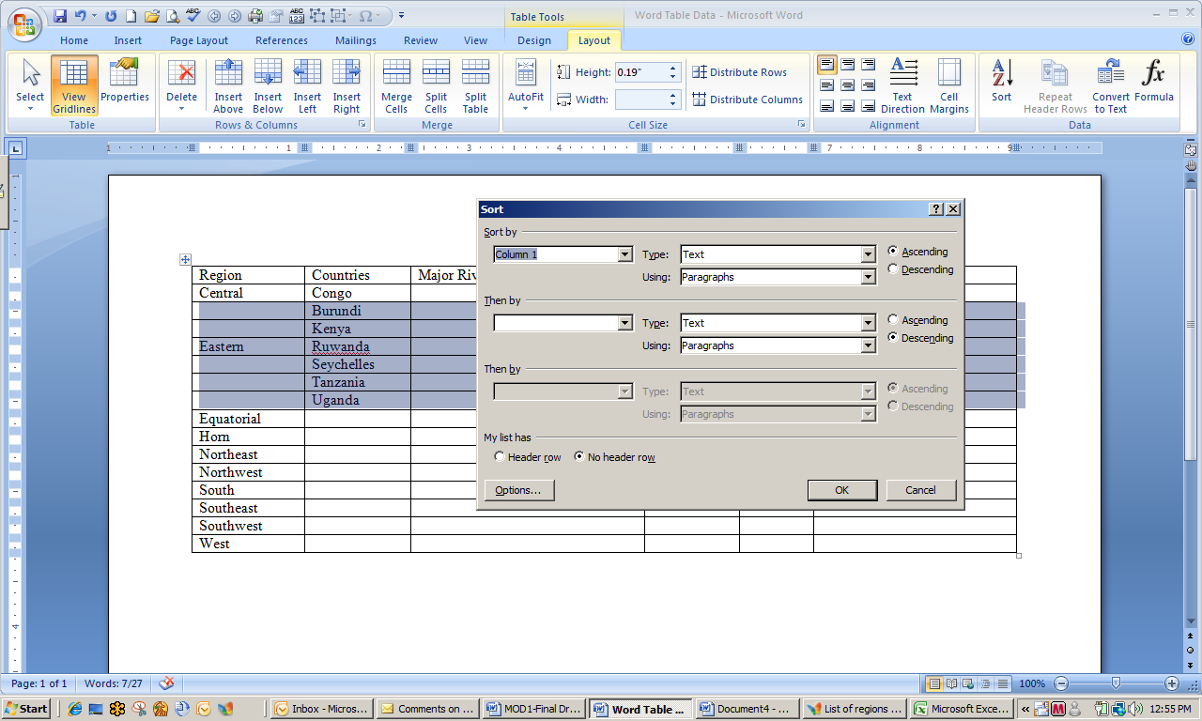

Sort dialog box

1. Select Column 2 from the **Sort by**: box. Make sure **Type**: Text, **Using**: Paragraphs, and **My list has** No header row are selected. Click OK.
2. You can then copy the word *Eastern* and paste it to the five empty region areas. Highlight the word Eastern, left click, type Ctrl V.
3. Move the cursor to any of the blank Eastern region cell and then type Ctrl V. Continue to do this until Eastern is entered into the other four table cells. Your table should resemble the one below.
4. Save the file and close.

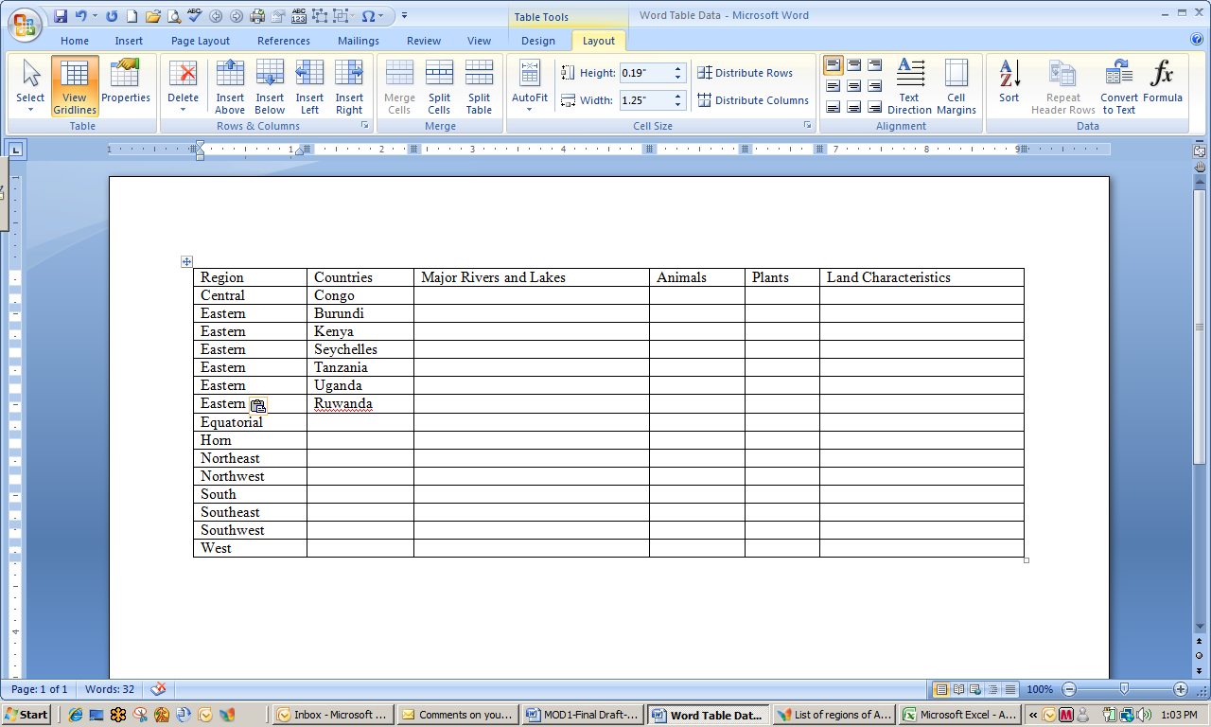Data Sorted in Word

Explore: Formatting a Word Table

Finally, you have all the data entered into your table and you are ready to start writing a first draft of the Geography section of the report; however you want to format the table to make it easier to read and more attractive. You can add the table to a Power Point presentation at a later point in the project.

Before you begin, note that a few region names have been changed from your original document due to a class discussion on the source documents. Cross-team collaborations discovered various ways to categorize some of the African data, so changes were made to have consistency in what is presented.

1. Open the document *Word Table Format.* Highlight the top row and insert a row above it. In the top left, type Africa Report Geography Data.
2. Highlight the entire first row. In the **Merge** section, click Merge Cells. Go to the **Home** tab, **Paragraph** section and center the data. Bold this title.
3. In the **Design** tab, **Table** **Styles** section, click the small arrow in the lower right section of the styles examples. Scroll over various styles. Word automatically previews the styles for you. Select a style.
4. Put a blank line between each region’s data. Highlight and bold all of the column headings.
5. Select the entire table. Place the cursor near the upper left corner of the table until a crosshair appears. Left click. In the **Design** tab, **Table Styles** section, click the small arrow to the right of Borders. Select All Borders.
6. Save as *[Your Name] Word Table Format.* Close all open programs.

Explore: Using Office Live Workspaces

Saving to MS Office Live

1. Open the MS Office Live sign-up page at http://www.officelive.com/
2. Click Get a FREE Workspace.
3. On the next page, you will be asked to type in your e-mail address. This should be an e-mail address that you can easily access from here.
4. You will next be prompted for a password and other information. Type the requested information. You will be able to access and use this Office Live workspace after this session.
5. After completion of the sign-up procedures, you will either see a screen similar to the one below, or a different screen that directs you to create a workspace.

**Note**: If you do not have access to e-mail during this session, your instructor will provide you with a url to access the MS Office Live Site.

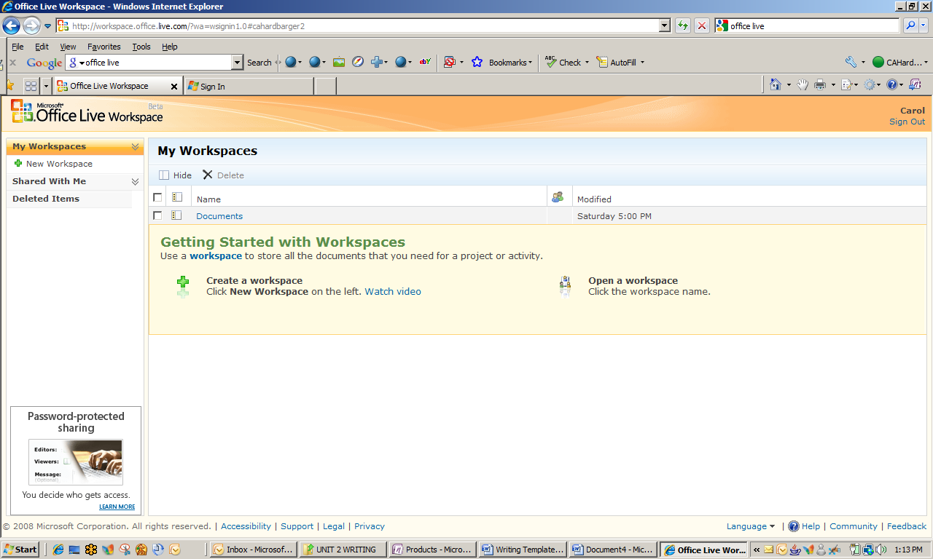

MS Office Live Workspace

1. 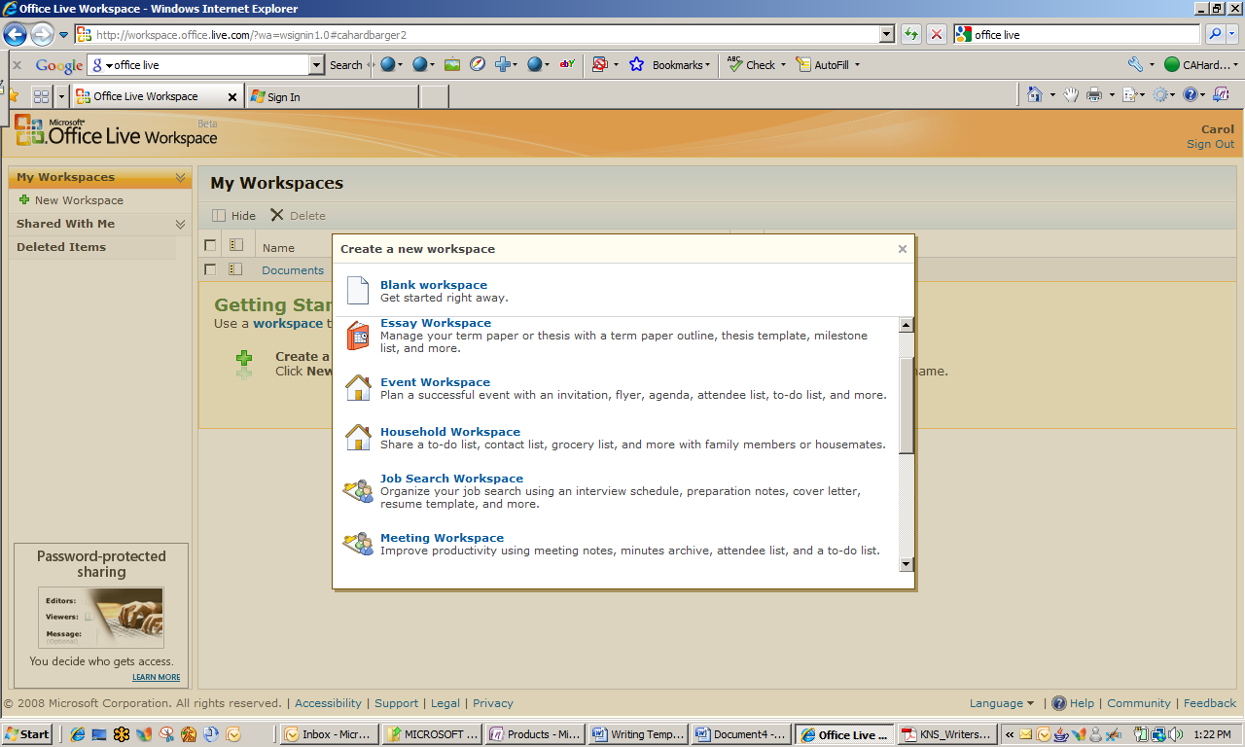Click New Workspace in the left side navigation pane. You will see a screen similar to the one at right.

Creating a New Workspace: Selection Menu

1. Scroll to and select Project Workspace in the **Create a new workspace**dialog box. A workspace will be created for you.
2. Note that there is a highlighted space in the bar at the top of the workspace, with directions for you to type a description (name) for this new workspace. Type [Your] 6th Grade Africa Report in the highlighted area and click anywhere outside the box to save the title.
3. Your project workspace will resemble the screen below.

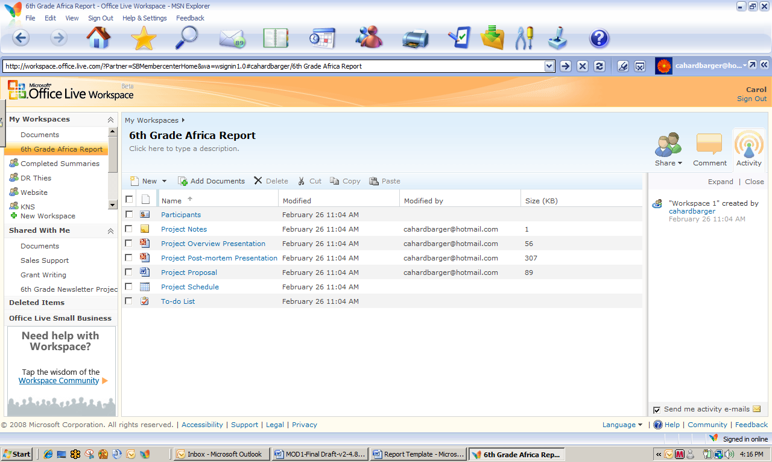

Project Workspace Templates

1. Click Add Documents. Upload the document, *Word Table Format*, to your workspace. Find the document *Africa Geography Report Draft* and also upload it to the workspace.
2. Note all the other features that the project workspace template provides for you and your students. Click at least three of the document types (e.g. Participants) and view their contents.
3. Leave the Office Live workspace open.

Explore: Using Office Live and Office Word 2007 to Retrieve and Edit a Document

Your students have worked hard to create data tables for their reports and are ready to begin the **revising and editing** process. They will be able to access each other’s documents on the Office Live Project workspace, review and edit, and save documents as separate versions.

1. If necessary, login and access your Office Live project workspace. To access the workspace, click [Your ] Africa Report Project in the left-side navigation pane.
2. You must add team members’ e-mail addresses to a document-share for them to access, revise, and resave your document. You may share the entire workspace, but for now you will share only a document. From your workspace, select the document *Africa Geography Report Draft* and then click Copy .
3. Open the documents workspace by clicking Documents under **My Workspaces** in the left navigation bar.
4. Click Paste. Your document should appear in the documents list.
5. Select your document from the check box in the left column. Click Share and then click Document from the pull-down menu.
6. Identify one partner from a person sitting next to you. Type your partner’s e-mail address in the **Editors:** bar. The e-mail address should be one that is accessible at this site.
7. Click Send in the lower right area of the screen. An e-mail message will be sent to your partner with a link to connect to your workspace. You will also receive an e-mail with a link to connect to your partner’s workspace.
8. If necessary, open your Office Live project workspace. Under the heading, **Shared With Me** in the left navigation pane, click Documents and then select your partner’s shared document to open it for editing.
9. Click the Edit icon in the top navigation bar of the workspace. The document will open in Word.

**Note**: You may be asked to install an Office Live update to enable online editing. Ask your instructor how to proceed if this occurs.

10.Click Review at the top of the Window. From the **Tracking** section click Track Changes. Edit the document in a few places. You may also add comments to the document by going to the **Comments** section and clicking New Comment.

**Hint:** There is content that may be removed because it is not geography-related.

1. When you are finished with your revisions, save the document to your work folder on your hard drive with a slightly different name. For example, *[Your] Content.docx* could be saved as *[Your] Content-2.docx*.
2. Upload the document to your Office Live workspace and give sharing rights to the document to your partner.
3. Leave both your document and the Office Live workspace open.

Explore: Creating a Final Draft and Saving as a New Version

Now that your first draft has been edited by a team member, you are ready to review your partner’s suggestions and create a **final draft**.

1. Open your Office Live workspace, if necessary, and go to the **Shared With Me** section on the left navigation pane.
2. You should have received an e-mail from Office Live that your partner has shared a new document with you. Click Documents and then open the edited document shared with you by your partner.
3. Review the changes that have been suggested by your partner and any comments made.
4. To REJECT A CHANGE, place the cursor over the deleted/added/changed area, right-click and select Reject Change from the drop down menu. The text area will revert to what you had originally written.
5. To ACCEPT A CHANGE, use the same process, but select Accept Change from the drop down menu. The changes will now appear in the text.

**Note:** You may also right click on the balloon on the right side review pane and select the desired option from the drop down menu.

1. Save this document as *[Your] Geography Report Final* to your hard drive and close it.

Using Office Live to Create and Save a New Version

1. Open your Office Live workspace, if necessary, and go to your project workspace. Open the document *[Your] Africa Geography Report Draft*.
2. Click the arrow by the lower right of the **Version** icon and select Add a new document version from the drop down menu. Locate the file, *[Your] Geography Report Final,* and choose it to upload to your project workspace.
3. The final draft is now uploaded to your workspace, but notice that it is still named a first draft. To change the name, click the project workspace in the left navigation pane and move the cursor over the document name. A window similar to the one below will appear.

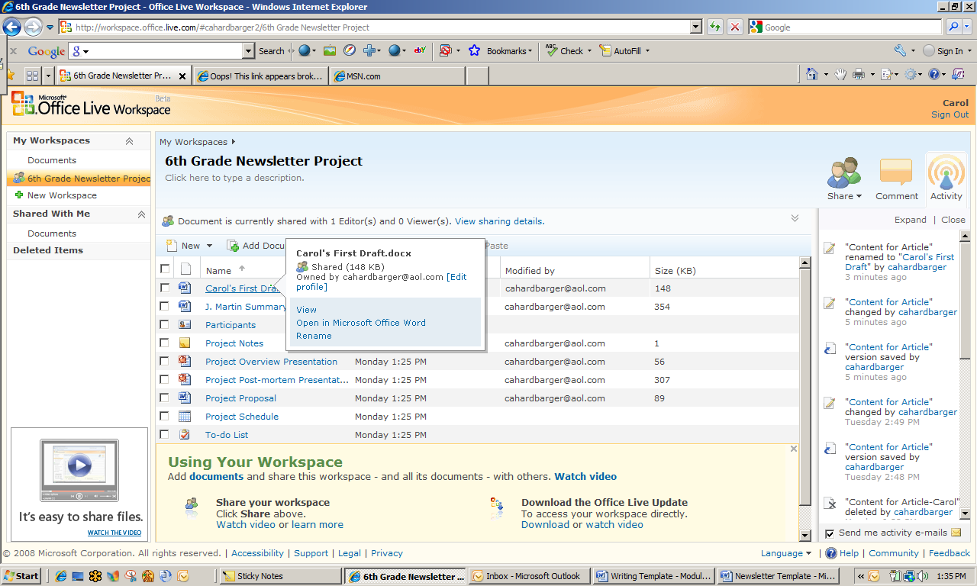

Project Document Options

1. Click Rename and type [Your] Geography Report Final Draft in the title bar. When you go to the project workspace, you should see the new name in your list of documents.
2. You now have the latest version available, but can also access, restore, or delete any of the previous versions at any time by clicking the Version icon in an open document.
3. Close all open documents, but leave the Office Live workspace open.

*Reflection*: When and why would Office Live be advantageous to your students?

Explore: Publishing a Report Using Word Templates

You and your team are happy—the social studies teacher is also covering the African continent and you will be completing a report on the Congo (Eastern region of Africa) for his class. You have collaborated on contents and edited each other’s documents. Now you are ready to put the final touches on the report to get it ready for submission. This will also help you review information you need to put in your English report.

Working with Text Boxes

1. Open the document, *Report Template.docx.* The report template has been formatted using Word 2007 and one of the built-in Word report templates. Note that the introductory section has already been added and there are built in text boxes for you to use to insert some of your material.
2. If necessary, open your Office Live project workspace and open the document, *[Your] Geography Report Final Draft.*
3. Add another text box to the report template. You will be able to add text about the Congo in these text boxes. Click the Insert tab on the task ribbon, go to the **Text** section and click Text Box. Click Draw Text Box from the drop down menu.
4. 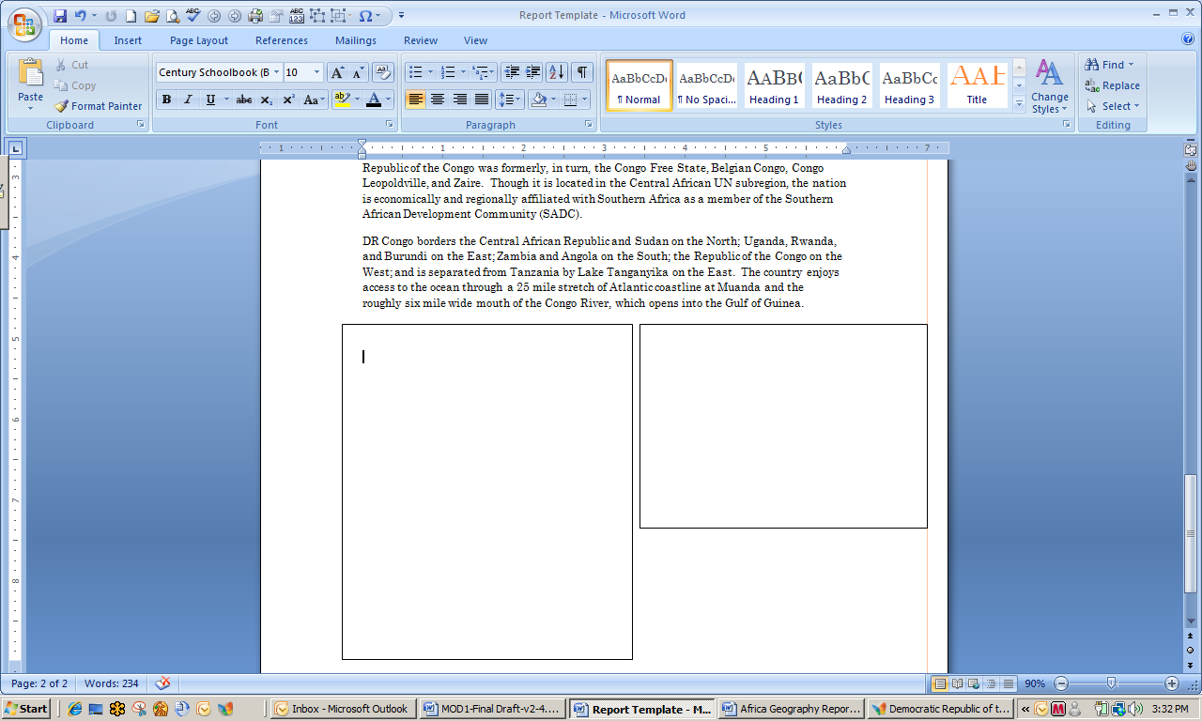Place the crosshairs on the report template to the right of the existing text box. Left click the mouse button to draw a text box the same width, but only about one-half as high as the one to the left. Your screen will show a document similar to the one below.

Report Template with Added Text Box (Right)

1. Copy and paste the title and content related to climate into the left text box. Copy and paste the title and first paragraph of content related to the Congo River in the right text box. You may have to adjust the shape and size of the text box – and/or cut and paste text to the right side text box.
2. At this point you want to leave the text box outlines in place.

Placing Clip Art

1. Click the Insert tab, go to the **Illustrations** section and click Clip Art. A **Clip Art** pane will appear to the right of your document.
2. Type the search term Africa in the **Search for**: box and then click Go. You will soon see available clip art from which you can select. Choose one of the two following samples:

MS Office Word: Sample Clip Art for Search of Africa

1. Move the cursor over the clip art you selected and right click the mouse. Select Insert. Note that the graphic may be inserted in an odd place so that you have to resize and move it.
2. Precisely click the graphic – not on any portion of a text box – to open the **Picture Tools, Format** ribbon. Go to the **Arrange** section and click Text Wrapping.
3. Click Tight or Square. You should now be able to resize and move the graphic to a position below the right side text box. Resize and position the graphic so that it fills approximately one-half to three-fourths of the available space and is pleasing to the eye.
4. It is now time to remove the outline around the text boxes. Place the cursor over a text box outline until the cursor changes to crosshairs. Click the outline. If necessary, click Format under the **Text Box Tools** tab to open the formatting ribbon. .
5. Go to the **Text Box Styles** section, click Shape Outline and then click No Outline.
6. Your report is now ready to distribute online!
7. Close all files and close Office Live.

Test Your Knowledge

The tasks below were addressed in this unit. Be sure you understand the terms used and are able to complete the tasks listed.

Review Me – Create outline and draft text

1. Open the document *Practice Outline.docx.* Highlight the words **To Do List***.* Type Ctrl B to bold the text. Change the font size to 16.
2. Type 3 – 4 additional to do items to the list. Highlight the text in all your steps (not the title). In the **Home** tab**, Paragraph** section, click the Bullet icon. Change the style of the bullet to resemble a box in a check list. (To change the style of the bullet, click the arrow by the bullet icon to reveal a menu of bullet styles.)
3. Using the outline provided, write an introductory paragraph. Save the document as *[Your Name] Practice Outline*. Leave the document open.

*Review Me – Save a Document to MS Office Live*

1. Open the document, *[Your] Practice Outline.docx*, if necessary.
2. Save to your MS Office Live project workspace.
3. Give sharing rights to the document to your session partner.

*Review Me – Retrieve and Edit a Document*

1. You should have received an e-mail giving you sharing rights to your partner’s document on your workspace. Open the document.
2. Make a few edits to the document. Save it with a slightly different name (to your hard drive).
3. Give your partner sharing rights to the edited document.
4. Review Me – Working with Text Boxes and Clip Art
5. Open a new document in Word by clicking the Office button and then New on the drop down menu*.* Draw a text box anywhere on the page. Change the shape and size of the text box.
6. Type She sells sea shells by the sea shore. . Enlarge the text to 14 font and change the font color to red.
7. Center the text. Remove the outline of the text box. Search for clip art (search: school) and place your chosen graphic anywhere on the document.
8. Close the text box and save the document as *[Your Name] Practice Text Box.*

Curriculum Connections

Students use computers in the classroom as a tool for both **productivity and learning**. Integrating computer skills with the academic curriculum **motivates** and **engages** students, and **prepares** them for the technology age. Below are a few ideas which can be used to integrate the skills covered in this unit into the academic curriculum.

Idea 1 – Journaling and Other Reflective Writing

* Students use MS Office Word 2007 to create daily/weekly journal entries that can be saved to an Office Live site or e-mailed for teacher comments. MS Office Online has several journal templates available for download.
* History teachers create wikis or blogs and have students post comments, respond to specific questions as part of regular course requirements, or analyze historical events.
* Industrial Arts students maintain online multimedia portfolios with sections for reflection on their own learning experiences, which can include digital representations.

Idea 2 – Collaborative Projects

* Earth science students contribute to web based climatology data collection activities that also have opportunities for live webcasts, e-mail, blogs, and other forms of collaboration and communication.
* Life science and/or agriculture student teams research, design, and construct a raised garden bed using the Internet, design tools, and collaborative writing and publishing.
* Technology students enrolled in different sections of a desktop publishing course collaborate on publishing the school newsletter.
* Economics students create and operate a papermaking business. Using an Office Live project workspace enables creation of to-do lists, calendars, and task lists, and storage of Excel documents containing financial records and other data.

Idea 3 – Differentiated Instruction

* Students who have writing or vision difficulties can use a word processor and enlarged font for enhanced communication.
* Use of a Tablet PC for teacher direct instruction enables students to interact with content using multiple senses.
* Creating a chart on the same Excel sheet as the data table promotes visualization of number and more complex mathematics relationships. Concepts such as slope (rise and run) and the relationship to the actual data are easier to envision.

Use the space below to write down additional curriculum connections ideas:

|  |
| --- |
|  |
|  |
|  |
|  |
|  |
|  |
|  |
|  |
|  |
|  |
|  |
|  |
|  |
|  |
|  |
|  |
|  |
|  |
|  |

Unit 2: Collaboration across the Content Areas

Unit Objectives

Conduct a search using Excel Research functions.

Sort and filter data in Excel datasheets.

Create Pivot tables and charts.

Collaboration across the Content Areas

Research shows that students have difficulty transferring information from one situation or curriculum to another when the situations appear different to them (Choi & Hannafin, 1997). Transfer of knowledge most easily occurs within the same or similar subject areas, but can also occur in situations where knowledge is learned in one subject area and then used in a second. Classroom learning and transfer of knowledge can both be enhanced when assigned tasks reflect the reasoning and complexity of real-world situations (Novak & Gowin, 1984).

Problem-based learning is ideal for facilitating instruction of various content and concepts in one subject area for use and reinforcement in another. This unit illustrates one way that technology can be used to teach and reinforce content and skills across a variety of subject areas in a unit focused on the continent of Africa:

* Mathematics
* Science
* Social Studies
* Language Arts
* Art
* Music

Technology Aids Interdisciplinary Planning

In the past, interdisciplinary teacher teams have had a difficult time manipulating their schedules to find common planning times. MS Office tools such as MS Office Live help the process by enabling teachers to **interact digitally** and to **collaborate** on a common unit of instruction without a lot of face time. Consider the following diagram that illustrates the process of developing an interdisciplinary unit of instruction.

Broad interdisciplinary unit goals

Content area goals to support interdisciplinary unit goals

Content area objectives

Content area instruction

Content area assessment

Interdisciplinary assessment

Using MS Office Live, teachers can organize student teams by content or as interdisciplinary groups.

To explore this process, activities in units 2 and 3 feature interdisciplinary student teams that study the continent of Africa. Their projects culminate in multi-media displays located in the lobby area of the school during an open house. Art and music chorale programs will also be featured highlights.

An interdisciplinary teacher team collaborated to develop the following goals and objectives for the unit. A few content-specific goals have also been provided as examples.

Example Interdisciplinary Goals:

* Understand the historical significance of Africa to the development of world civilizations.
* **Example: Content-Specific Goals**
  + Science students will understand how the natural resources of Africa have influenced world development, culture, and trade.
  + Social studies students will understand the relationship between migration patterns and the development of other civilizations.
  + Mathematics and science students will understand the relationship between disease and changes in population patterns in various parts of the African continent.
* Understand the impact and influences that African culture and experiences have had on other regions of the world.
* **Example: Content-Specific Goals**
  + Art students will understand and appreciate how African art and culture have influenced the culture and traditions of other regions of the world.
  + Music students will understand and appreciate how African music traditions have influenced the music of other regions of the world.
* Appreciate the relationships between several American (or other cultural) art and music genres and African cultural practices.
* Understand the current and historical economic linkages between Africa and other nations.
* Develop theme-based (environment, social issues, culture, etc.) project artifacts for display during open house.

Example Content-Specific Objectives

|  |  |
| --- | --- |
|  | Content area objectives |
| Math | Graph changes in population over the past 20 years in regions of Africa. |
| Science | Analyze desertification and water use in Africa and their impact on the environment and the economy. |
| Social Studies | Create a map of Africa that illustrates the geographical differences that exist on the African continent as well as the locations of capitals and other key cities, commodities and agricultural products |
| Language Arts | Create a newsletter focused on African continent history and culture. |
| Art | Create an art project based on research on tribal ceremonial masks. |
| Music | Build and play an African thumb piano and compose original music for it. |

Now that you have some idea of what an interdisciplinary project unit looks like, examine the following mathematics learning activity.

Integration Project Lesson Plan

| KNS  For Standards-based, Student-centered, Technology-rich Learning | Teacher: | Daniel Watkins |
| --- | --- | --- |
| School/District: | Panhandle Middle School |
| Subject Area(s) Addressed: | Mathematics |
| Grade Level(s)/Course: | 7th Grade |
| Date Submitted: | July 1, 2009 |
| Lesson Duration: | 1 90-minute lab period |

|  |  |  |
| --- | --- | --- |
| Unit Title | Experiencing Africa | |
| Lesson Title | Population Trends – Introduction to Population Mathematics | |
| General Lesson  Outcomes | Students have completed instruction on basic use of Excel as a database. The previous three lessons included activities in sorting and filtering. Upon completion of this lesson, students will   1. Define terms associated with population mathematics. 2. Interpret charts and graphs related to population trends. 3. Calculate growth and decline rates. | |
| **Academic Standards Addressed** | Texas Essential Knowledge and Skills (TAKS)  7.1 Number, operation, and quantitative reasoning. The student represents and uses numbers in a variety of equivalent forms.  7.3 Patterns, relationships, and algebraic thinking. The student solves problems involving proportional relationships.  7.9. Measurement. The student solves application problems involving estimation and measurement.  7.10. Probability and Statistics. The student recognizes that physical or mathematical models can be used to describe the probability of real-life events.  7.11. Probability and Statistics. The student understands the way a set of data is displayed influences its interpretation.  7.13. Underlying processes and mathematical tools. The student applies Grade 7 mathematics to solve problems connected to everyday experiences, investigations in other disciplines, and activities inside and outside of school.  7.14. Underlying processes and mathematical tools. The student communicates about Grade 7 mathematics through informal and mathematical language, representations, and models.  7.15. Underlying processes and mathematical tools. The student uses logical reasoning to make conjectures and verify conclusions. | |
| **Technology Standards Addressed** | Technology Standards (NETS – http://www.iste.org)   1. Creativity and Innovation.   Students demonstrate creative thinking, construct knowledge, and develop innovative products and processes using technology. Students:  a. apply existing knowledge to generate new ideas, products, or processes.  b. create original works as a means of personal or group expression.  2. Communication and Collaboration  Students use digital media and environments to communicate and work collaboratively, including at a distance, to support individual learning and contribute to the learning of others. Students:  a. interact, collaborate, and publish with peers, experts, or others employing a variety of digital environments and media.  b. communicate information and ideas effectively to multiple audiences using a variety of media and formats.  d. contribute to project teams to produce original works or solve problems.  3. Research and Information Fluency  Students apply digital tools to gather, evaluate, and use information. Students:  plan strategies to guide inquiry.  a. locate, organize, analyze, evaluate, synthesize, and ethically use information from a variety of sources and media.  c. evaluate and select information sources and digital tools based on the appropriateness to specific tasks.  d. process data and report results.  4. Critical Thinking, Problem Solving, and Decision Making  Students use critical thinking skills to plan and conduct research, manage projects, solve problems, and make informed decisions using appropriate digital tools and resources. Students:  b. plan and manage activities to develop a solution or complete a project.  c. collect and analyze data to identify solutions and/or make informed decisions.  5. Digital Citizenship  Students understand human, cultural, and societal issues related to technology and practice legal and ethical behavior. Students:  a. advocate and practice safe, legal, and responsible use of information and technology.  b. exhibit a positive attitude toward using technology that supports collaboration, learning, and productivity.  c. demonstrate personal responsibility for lifelong learning.  d. exhibit leadership for digital citizenship.  6. Technology Operations and Concepts  Students demonstrate a sound understanding of technology concepts, systems, and operations. Students:  a. understand and use technology systems.  b. select and use applications effectively and productively.  d. transfer current knowledge to learning of new technologies. | |
| **Teacher-Led Activities** | Students have been introduced to population in both science and social studies classes. We will now begin to discuss population in the context of mathematics. Students will complete a module on population growth and rates using an interactive website produced by the World Bank. They have previously used the same site in science and social studies, and will now complete the math related activities.   1. Provide students with instruction sheet to access the population education website. 2. Make certain all computers are up and running and that students are able to access the Internet. . 3. Assign related homework activities on calculation of growth and decline rates for African countries. Students will use a datasheet copied from World Bank website. 4. Remind students of the importance of using valid data. | |
| **Student-Centered  Activities** | Students have all previously used the interactive World Bank site to review content on population growth from a social science and biodiversity perspective. They have responded to questions related to those issues, online, and are now ready to complete math-related activities, primarily the interpretation of charts and graphs and the actual calculation of population growth and decline rates.   1. Access interactive World Bank website following printed instructions. 2. Following instructions on handout, review online graphs and charts and complete activities. 3. Calculate population growth and decline rates as indicated on website. 4. Complete tables with predictions about population based on calculated rates. 5. Complete homework assignment related to population growth rates in African countries. | |
| **Resources Needed** | Content resources (books, articles, speakers, handouts, materials, etc.) | Software/Web Resources (CD-ROMs,URLs, etc.) |
| Handouts– Copied data table on sub-Saharan population data to use with homework problems.  Handout – Homework problems. | World Bank Learning Module on Population Growth Rates  <http://www.worldbank.org/depweb/english/modules/social/pgr/index.html>  World Bank Population Data Table for sub-Saharan Africa  <http://www.worldbank.org/depweb/english/modules/social/pgr/datasubs.html> |
| Hardware (computers, TV, DVD, etc.) | Other media, video, satellite, etc. |
| Computer lab with minimum 25 desktops or mobile cart with individual laptops.  Calculators, if needed. Students should be encouraged to use PC calculator tools. |  |
| **Student Assessment Strategy** | 1. Assessment of homework problems. 2. Responses to questions on unit test. 3. Project participation and evaluation of completed products. | |

Exploring Databases Using MS Office Excel 2007

What is a database? A **database** is simply an **organized collection of information**. In this information age we are surrounded by databases: file cabinets, telephone books, dictionaries, and medical records are all collections of information organized so that the contents can easily be accessed, managed or updated. A grade book, for example, contains many different types of information such as words, numbers, and pictures. Databases can be **paper or electronic**.

In the following activities, you will be using a simple example of a database created in Excel entitled Asia and Africa Data. As a database, the Asia and Africa Data file contains information that is related in some way. You may be asking, “What is the difference between a spreadsheet and a database?” A database is more powerful than a spreadsheet because it can be used to sort and filter specific pieces of data for use in various applications. MS Office Excel 2007 can be used as either a spreadsheet or a database.

The file Asia and Africa Data is called a **database file**. The information in this file is stored in a format called a table or list. Each separate database file stores information about one topic, in this case the countries of Africa and Asia. The Asia and Africa Data database file is made up of **records or cases**, each one a set of information about one country. The information contained in the records occupies the rows of the table. For example, one row in the Asia and Africa Data file contains all the available information about the African country, Kenya.

The columns are labeled as **fields**, with each field representing a unique and specific piece of data about each country (record). In the Asia and Africa Data database, the fields (columns) might be labeled as and contain the country’s name, capital, population, area, as well as other facts.

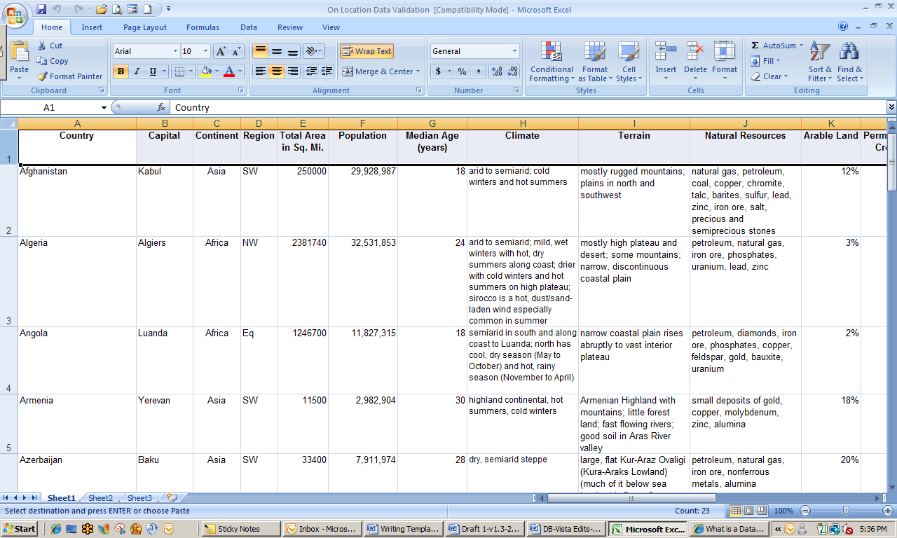

Field

MS Office Excel: Field and Record

Record or Case

Record

Databases can be powerful learning tools. During the information gathering stage of a unit for example, they can be a valuable resource, allowing students opportunities for **organizing** and **reorganizing data**, and for **searching**, **sorting**, and **retrieving information**. Databases provide students with a method to determine patterns and relationships, to predict, and to support their hypotheses. While building a database, students are involved in the process of discovering and classifying data. All of these activities improve their **critical thinking skills**. As students interact with information in meaningful ways, retention and understanding increase.

When used as a database, Excel has the flexibility to build data lists from any source in any curriculum area. Students can use databases for numerous problem solving projects such as collecting and analyzing data for science experiments, research papers, and literary studies. As a teacher, it is important to create activities that allow students to compare, analyze, synthesize, and evaluate.

Explore: Navigating in MS Office Excel 2007

Windows Vista

1. Click StartMenuButton and open Microsoft Office Excel 2007. If MS Excel does not show up on the Start menu, click All Programs, Microsoft Office, and select Office Excel 2007. You can also type Excel in the Search box.
2. Open the document titled *Asia and Africa Data*.*slxs*. This database contains important information about countries in the continents of Africa and Asia.
3. Using the right side scroll bar, scroll to the last record in the database.
4. How many countries are included in the database?____________________

**Note**: Row 1 contains the *Fields* labels for the database.

1. Move the cursor to the far left edge of **row 3**. The cursor will change to . Click the left mouse button and notice that the entire row is now highlighted. You could perform an action at this point that would affect all data in the row; for example, try bolding and then unbolding the text.
2. Move the cursor to the top of the **column F** and when you see , click the left mouse button. The entire column is highlighted. Again, any action you perform would affect all entries in the column.
3. The intersection of **row 3** and **column F** is known as a *cell.* It is written as **F3** and contains the population of the Congo. Go to (cell) **K15**.
4. What field is represented in **K15**? ____________ Country?_____________
5. To what cell would you go to find the unemployment rate of Chad?______
6. Close the file. It should not be necessary to save it, but if you are prompted to do so, save it with the same name.

Explore: Using Excel Research Features

Students in the various courses can access the database, add information to it related to their content areas, and save it to the Office Live workspace for use by the team.

1. Open the file *Asia and Africa Data Search.slxs.* Highlight **column A**. In the **View** tab**, Window** section, click Freeze Panes. Select Freeze First Column. The list of all the countries will now be visible to you as you work across the database.
2. Some of the countries (China, India, and Indonesia) have missing data, which will be filled in by team members.

* Math: Median age, population
* Social studies: Type of government, percent arable land
* Science: Climate, natural hazards

1. Go to the **Review** tab**, Proofing** section, and click the Research icon. The **Research** pane should appear to the right of your document.
2. Type China median age in the **Search for:** box and then select Live Search from the pull down menu. Search results similar to those below should appear.

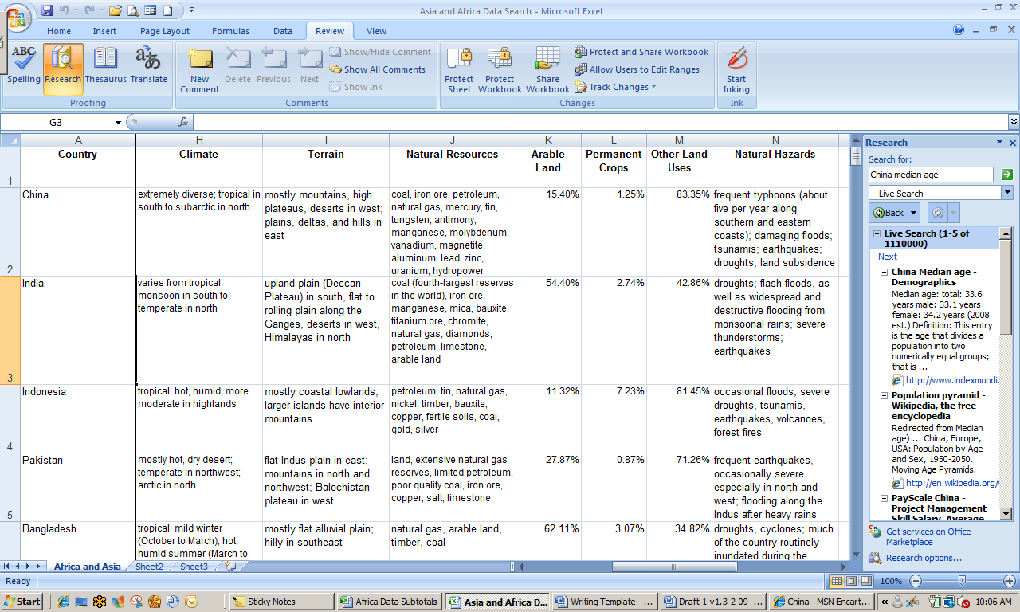

Search Results Displayed in Research Pane

1. Go to **cell G2** in the database and type in the total median age for *China*. Also add the median age for *India.*
2. Find the population of *China* and add to the database. You may have to click a hyperlink in the search results to find the actual data, but to save time you should always scroll through the results to see if any listings in the Research pane provide you with the actual information you need.
3. Search for the climate and type of government in *Indonesia* and add those data to the database.

Each of the content areas involved in the team project has now had the opportunity to use Excel research features to add information to the database.

1. Save the file as *[Your Name] Africa and Asia Data Search* and close it.

Explore: Sorting data

Large databases can contain, literally, millions of individual pieces of information. Excel provides you with the tools to easily sort and work with those data important to your task.

1. Open the file *Asia and Africa Data Sort.slxs*. Note that **column A** (field: *country*) has been sorted in alphabetical order. Scroll to the last record in the database, Zimbabwe, and make a note of the data in **E102**, **F102**, and **G102**.

E102 _______________ F102 _______________ G102 ______________

1. Click the top of column A to highlight the entire column. In the **Home** tab, **Editing** section, click Sort & Filter. Click Sort Z to A.
2. Excel automatically asks you if you want to include all fields in the sort or if you only want to sort **column A**. Under the heading, *What do you want to do?* make sure that Expand the selection is selected and click Sort.
3. The entire database should be sorted from Z to A. Check the information for Zimbabwe found in **E2**, **F2,** and **G2**. Does it match what you recorded above (#1)?
4. Resort **column A** so that the database reverts to alphabetical order, A to Z. Leave the file open for the next activity.

Sorting by Multiple Criteria

Excel 2007 allows you to choose more than one criteria for sorting.

1. Click the area at the top left of the database, at the location of a small triangle, to highlight the entire spreadsheet. Click Sort & Filter. Click Custom Sort. You should see a pop-up that resembles the following:

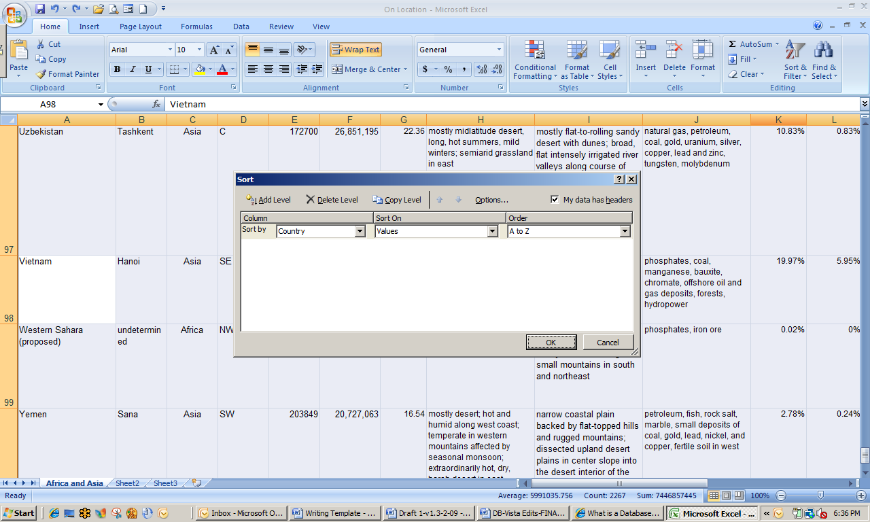

Excel Sort Criteria

1. Using the pull down menus in the **Sort by** row, select Population, Values, and Largest to Smallest.
2. In the upper left, click Add Level. Note that a new line with the heading **Then by** appears. Using the pull down menus in the **Then by** row, select Median Age, Values, and Largest to Smallest.
3. Make sure the box **My Data Has Headers** in the upper right corner is checked. Click OK.
4. Save as *[Your Name] Asia and Africa Data Sort*. Leave open.

Explore: Filtering Data

Your math students have successfully sorted data by population and median age, but they only want to work with the data from the continent of Africa. Excel allows you to **filter data**, in this case all the records of countries in Africa, so that you can use only the data you want.

1. If necessary, open the file *[Your]Asia and Africa Data Sort.* Move the cursor to the top of **column C** until you see and **left click** to highlight the column. In the **Home** tab**, Editing** section, click Sort & Filter.
2. Select Filter from the drop down menu. You should see a small box with an arrow in cell **C1**, labeled *Continent.*  (See Figure A.)
3. Click the arrow and then select Text Filters. This will give you two options for filtering criteria (See Figure B.) Deselect Asia, which will leave Africa checked as a filter.

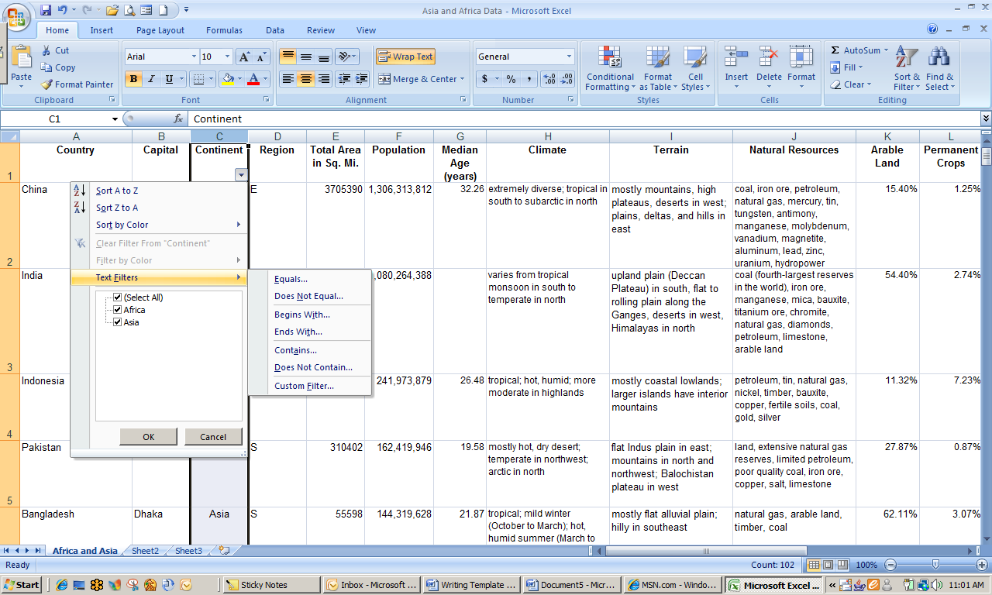

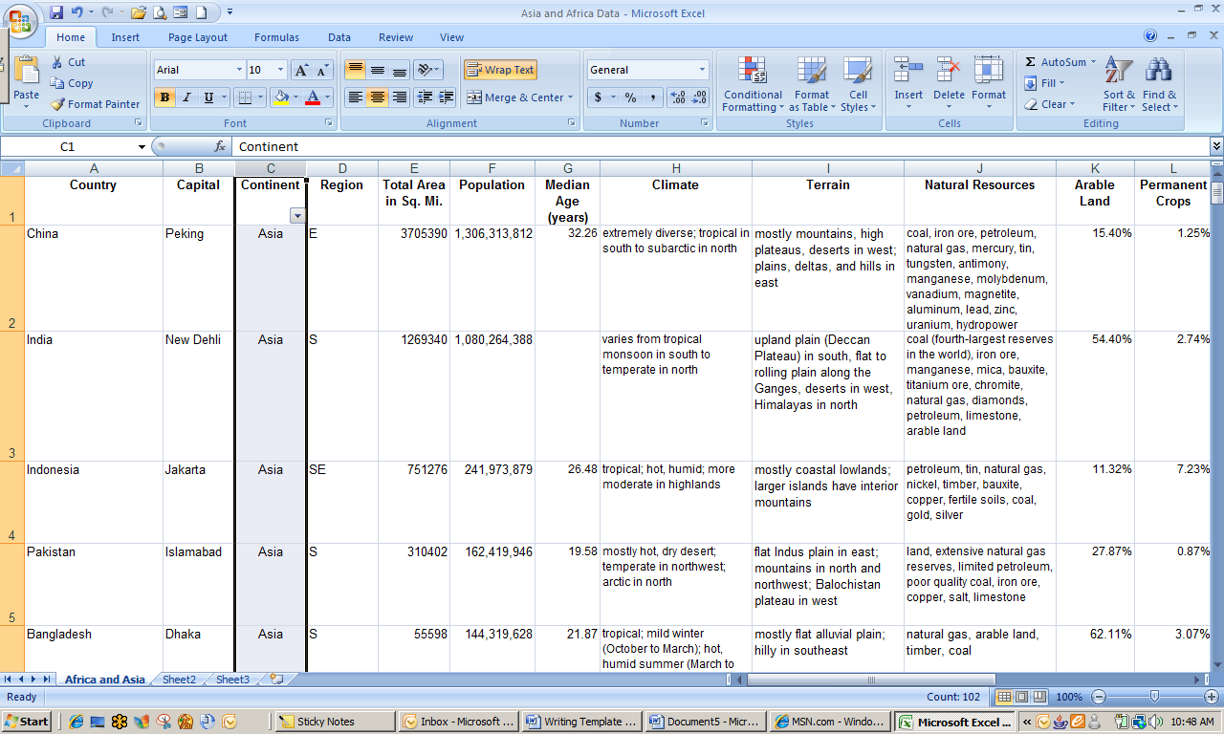

Figure A Figure B

1. Click OK. Look in the lower left corner of the Excel sheet. Note how many records remain out of the original 101. ­_______________
2. Save as the same file name and leave open.

Using Other Excel Tools to Aid Your Project

Your students have a few questions about some of the text and other information found in the database. Excel provides many of the same **research and editing capabilities** found in MS Office 2007 Word and other Office applications.

Some of your students have asked, “What does arable land mean?” You don’t have to send them to a paper dictionary.

1. Click cell K1, labeled **Arable Land**. In the **Review** tab**, Proofing** section, Click Thesaurus. The **Research** pane should appear to the right of your document.
2. Note that Arable Land is already “typed” in the **Search for:** box. Also, notice that no results have been found in a search of the online Thesaurus.
3. Click the arrow to the right of the box below the **Search for**: box. Select the Encarta Dictionary option from the pull down menu. You will see several definitions for the term *arable land.* Read the definitions and then close the Research pane.

The percent of arable land—land for growing crops—is going to be directly related to things such as topography and climate. It will also affect the economics of a country. Your math students will use tools available with Excel to calculate some interesting statistics about the African countries to share with their team members in other classes.

1. Scroll through the database and place the cursor in cell **K102**. This should be the cell directly below the last entry in column K. Note the **formula bar** at the top of the page and the symbol *fx* as shown below.

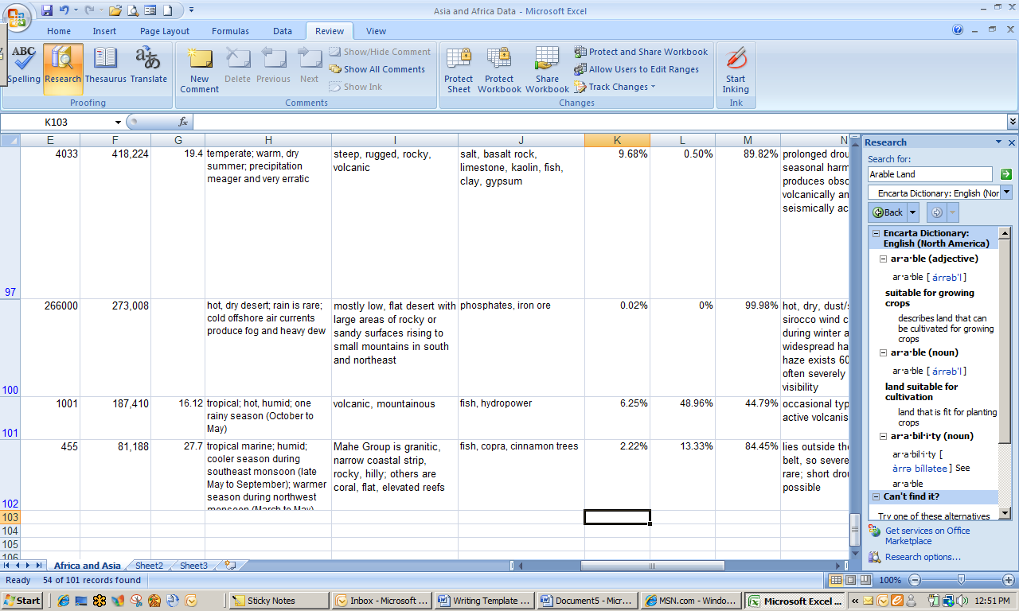

1. Click fx to reveal the **Insert Function** dialog box. Type Average in the **Search for a function**: box. Click OK, which opens the **Function Arguments** dialog box.
2. Placing the cursor below the last entry in any column will calculate the value of all numbers in that column. Note that the box labeled **Number 1** in the dialog box contains the number phrase **K2:K102**, which represents the entire array of data in **column K**.
3. Click OK. The average percent arable land on the continent of Africa is shown in cell **K103**. Write it here. _______________
4. Sort the data in **column K** from *largest to smallest*. Remember to expand the selection beyond that column when prompted.

Grouping Data

Your math students are going to separate the African continent data into two groups: 1) those countries with percent arable land greater than the average and 2) those countries with percent arable land less than the average. The social studies students on the various teams will then use those data for comparisons of percent arable land to other demographic indices.

1. Place the cursor on the highlighted “8” representing **row 8** and left click. The entire row should now be highlighted. While continuing to hold the left mouse button, scroll to **row 49**, which should then be the last row in the dataset that is highlighted.
2. Leave all selected rows highlighted. Open the **Data** tab and go to the **Outline** section. Click Group. Notice the extra space at the left side of the dataset and the that has appeared. _
3. Certain rows in **rows 8-19** are grouped to contain the African countries that have percent arable land greater than the average for the continent.
4. Save the file as [*Your Name*] *Grouped Data*. Leave the file open.

Using the Automatic Calculating Functions

Excel has a built-in function that provides three useful pieces of information: record count, sum, and average.

1. Highlight **column F** and then look at the task bar directly below the datasheet. Some of the calculated figures may not be useful. For example, the count in this example reflects one more than the actual because the header is also being counted.
2. What is the average population of the 54 African countries in your database?

_________________________

1. What is the total population of Africa according to the information in your database?

­­­­­­­­_________________________

1. Save and close the file.

Explore: Creating a Pivot Table

Your math students have now separated the African continent into groups that represent countries above and below the average percent arable land. They have one more task before they save the database to an Office Live workspace to share with their team members the other curriculum areas who are also working on the project.

A **pivot table** enables the user to easily summarize, explore, analyze, and present summary data. The data can also be visualized using the **Excel Pivot Table Report** function.

1. Open the file *Africa Data Subtotals.* Open the Africa datasheet by clicking the tab labeled Africa at the bottom left of the window.
2. Since the Social Studies team members will be examining regional characteristics of the African continent, an additional sort is necessary. Highlight **column D** (*field: Region*) and sort alphabetically A to Z. Countries are now sorted into groups by region. Remember to expand the sort when prompted.
3. Place the cursor in any cell. In the **Insert** tab**, Tables** section, click the Pivot Table icon. A **Create Pivot Table** dialog box will appear.
4. The entire table, as the table range, is already selected for you. In the section **Choose where you want the Pivot Table report to be placed**, make sure that New Worksheet is selected.
5. Click OK. Note that you are now in a new worksheet and a **Pivot Table Field List** pane has appeared to the right of the worksheet.
6. From the **Choose fields to add to report**: choices, select the following:

* Region
* Total area in Sq. Mi.

1. Right click Sheet 1 at the bottom left of the window and select Rename. Type Area.
2. Return to the Africa worksheet. Create a second pivot table using the Region and Population fields and rename the sheet Population.
3. Save as *[Your Name] Africa Data Subtotals* and leave open.

Explore: Creating Pivot Charts in Excel

The math students have organized data for the countries of Africa for use by social studies and other classes and saved the Excel file to an Office Live project workspace. Team members from the social studies class have accessed the file and will be creating charts or graphs to help them with their project assignments.

1. If necessary, open the file *[Your] African Data Subtotals.xsls*. Open the Sheet, Area, by clicking the tab at the bottom left corner of the window.
2. Click anywhere on the pivot table to access the **Pivot Table Tools** ribbon. Click the Options tab, go to the **Tools** section, and click the PivotChart icon.
3. Select Bar chart from the options and the **first** bar chart design in the menu. A chart will automatically be created in the same worksheet.
4. Click the word, Total, in the **Title** text box, then click the word twice to highlight it. Type Total Area by Region (Sq. Mi.).
5. Click anywhere on the chart area. Click the Layout tab, Data Labels, and then select Outside End from the drop down menu. Your screen should look similar to the one below.

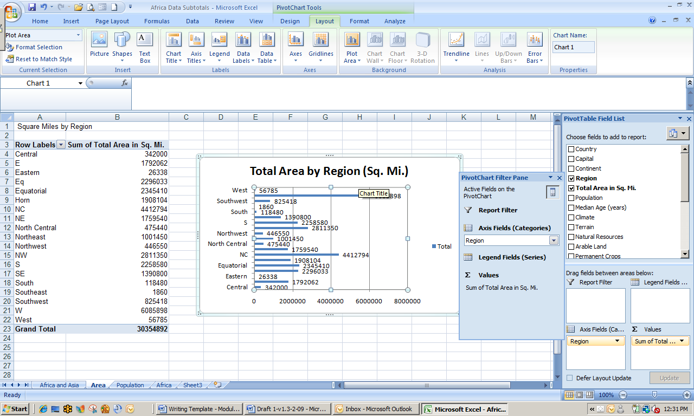 Excel Pivot Table and Pivot Chart

1. Access the Population worksheet. Create a pie chart that shows the total population by region for all the African countries.
2. When you get ready to add the data labels, select Best Fit as the option for placement.
3. Save the file and close.

Test Your Knowledge

The tasks below were addressed in this unit. Be sure you understand the terms used and are able to complete the tasks listed.

Review Me – Managing Data Files

1. Open the file African Highways Report.xsls.
2. Rename Sheet 1 as All.
3. Bold the entire column of country names.
4. Research to find current major ruler of Cameroon. _________________________
5. The longitude _______________ and latitude of Ethiopia. _________________

Review Me – Sorting and Filtering Data

1. Highlight the entire worksheet to conduct a custom sort by continent, region, and then population (largest to smallest).
2. Filter the data so that only the data for African countries remain.
3. Highlight and copy datasheet. Paste into sheet 2.
4. Rename sheet 2 as Africa.
5. Remove filter from sheet 1 (All data).

Review Me – Pivot Tables and Charts

1. Using the Africa (only) data, create a pivot table showing totals of highways by region.
2. Create a pie chart using pivot table data. Add data labels.
3. Change the title of the pie chart.

Curriculum Connections

Students use computers in the classroom as a tool for both productivity and learning. Integrating computer skills with the academic curriculum motivates and engages students, and prepares them for the technology age.

Many local, regional, and national organizations provide data that can be downloaded to Excel for use in a variety of analyses. Conduct a search using the MSN or another search engine of the phrase student datasets. Look at a few of the search results. Below are a few ideas which can be used to integrate the skills covered in this unit into the academic curriculum.

Idea 1 – Collecting and Managing Real-Time Data

* Students in grades 1-3 collect weather or stream data, and learn how to add it to an Excel datasheet prepared by the teacher.
  + Grade 3 students practice writing interpretations of data for science class.
* Students in grades 6-8 math classes validate these weather/stream data using number logic and reasoning. They also experiment with various types of graphs and charts to aid their understanding of which type of data work with which type of chart and why.
* Students in grades 7-12 math classes conduct statistical analyses using the data. Younger students can also use the data for a variety of calculations including averages.

Idea 2 – Using Data from Other Sources

* Using the research capabilities of Office 2007, teams of social studies students create a database for an assignment on Canada.
* Using a dataset downloaded from the Harvard Center for International Development, students enrolled in an economics class examine the relationship between geography and economic development. [http://www.cid.harvard.edu/ciddata/ciddata.html]

Idea 3 – Enhance Written and Oral Presentations

* Students create (or download) datasheets and create corresponding tables and charts to integrate into Word documents and PowerPoint presentations.
  + Students change data entries in Excel to illustrate discussions of variable manipulations (e.g. change over time) in papers or presentations, and discuss trends and/or projections.

Use the space below to write down additional curriculum connections ideas:

|  |
| --- |
|  |
|  |
|  |
|  |
|  |
|  |
|  |
|  |
|  |
|  |
|  |
|  |
|  |
|  |
|  |
|  |
|  |
|  |
|  |
|  |

Unit 3: Collaboration on Presentations

Unit Objectives

Navigate in MS Office Power Point 2007 to create a presentation.

Synthesize data to develop content for a presentation.

Insert text boxes, graphics, charts, pictures, and hyperlinks in slides.

Animate slides to enhance presentation effects.

Collaborations on Presentations

For the African Continent Project, student teams present their data in a variety of ways including displays of their art and music products, posters with graphs and charts, and Power Point presentations. Creating presentations teaches a number of skills, not the least of which is how to synthesize data to present the key points as well as the most important and interesting information.

The team decided to create a presentation that highlights key information from each of the 11 regions. Each subject area will contribute to the presentation in the following ways:

* Mathematics – Population and area data
* Science – Climate data
* Social Studies – Natural resources data
* Language Arts – Final editing
* Art – Presentation design, cultural highlights and art
* Music – Music highlights embedded into presentation

The following lesson plan was developed by a science teacher to accompany the integrated unit.

Integration Project Lesson Plan

| KNS  For Standards-based, Student-centered, Technology-rich Learning | Teacher: | William Adler |
| --- | --- | --- |
| School/District: | Homestead Middle School |
| Subject Area(s) Addressed: | Science |
| Grade Level(s)/Course: | 7th |
| Date Submitted: | July 1, 2009 |
| Lesson Duration: | 2 50-minute periods. |

|  |  |  |
| --- | --- | --- |
| Unit Title | Experience Africa | |
| Lesson Title | Climate and Weather in Africa | |
| General Lesson  Outcomes | Students have been working in social studies classes to divide the countries of Africa into regions. The important issue of desertification will be covered in science. Students will be contributing the data from today’s lesson to their interdisciplinary team’s Power Point presentation.   1. Define climate types that are predominate to the African continent. 2. Identify primary climate for each country and region. 3. Discuss factors that influence climate and weather on the African continent. | |
| **Academic Standards Addressed** | National Science Education Standards (http://www.nap.edu/openbook.php?isbn=0309053269)  NS 5-8.2.3 Physical Science - Transfer of energy  NS 5-8-3.4 Life Science - Population and ecosystems  NS 5-8-4.1 Earth and Space Science - Structure of the earth’s systems  NS 5-8-4.2 Earth and Space Science - Earth’s history  NS 5-8-4.3 Earth and Space Science - Earth in the solar system  NS 5-8-6.2 Personal and Social Perspectives - Populations, resources, and environments  NS 5-8-6.3 Personal and Social Perspectives - Natural hazards  NS 5-8-7.2 History and Nature of Science - Nature of science | |
| **Technology Standards Addressed** | Technology Standards (NETS – http://www.iste.org)   1. Creativity and Innovation.   Students demonstrate creative thinking, construct knowledge, and develop innovative products and processes using technology. Students:  a. apply existing knowledge to generate new ideas, products, or processes.  b. create original works as a means of personal or group expression.  2. Communication and Collaboration  Students use digital media and environments to communicate and work collaboratively, including at a distance, to support individual learning and contribute to the learning of others. Students:  a. interact, collaborate, and publish with peers, experts, or others employing a variety of digital environments and media.  b. communicate information and ideas effectively to multiple audiences using a variety of media and formats.  d. contribute to project teams to produce original works or solve problems.  3. Research and Information Fluency  Students apply digital tools to gather, evaluate, and use information. Students:  plan strategies to guide inquiry.  a. locate, organize, analyze, evaluate, synthesize, and ethically use information from a variety of sources and media.  c. evaluate and select information sources and digital tools based on the appropriateness to specific tasks.  d. process data and report results.  4. Critical Thinking, Problem Solving, and Decision Making  Students use critical thinking skills to plan and conduct research, manage projects, solve problems, and make informed decisions using appropriate digital tools and resources. Students:  b. plan and manage activities to develop a solution or complete a project.  c. collect and analyze data to identify solutions and/or make informed decisions.  5. Digital Citizenship  Students understand human, cultural, and societal issues related to technology and practice legal and ethical behavior. Students:  a. advocate and practice safe, legal, and responsible use of information and technology.  b. exhibit a positive attitude toward using technology that supports collaboration, learning, and productivity.  c. demonstrate personal responsibility for lifelong learning.  d. exhibit leadership for digital citizenship.  6. Technology Operations and Concepts  Students demonstrate a sound understanding of technology concepts, systems, and operations. Students:  a. understand and use technology systems.  b. select and use applications effectively and productively.  d. transfer current knowledge to learning of new technologies. | |
| **Teacher-Led Activities** | Students have worked in social studies to divide the countries of Africa into regions. They will now conduct internet research to identify the type of climate for each country and that is predominate to each region.   1. Review regions of Africa briefly as indicated on maps that students have created. 2. Divide students into groups of two. Provide each team with assignment handouts to explore two climate and influencing factors in one region per team. 3. Make sure that each team is able to access Internet and Excel African continent database. 4. Monitor and assist as needed. | |
| **Student-Centered  Activities** | 1. Discuss assignment and divide work responsibilities. 2. Define and describe weather and climate terms included on worksheet using Encarta reference library. 3. Conduct research to determine influences on climate types. 4. Access website and identify predominate climate in each country in assigned region. 5. Add climate type and description to Excel database. 6. Create 1-page write up to describe climate in assigned region. | |
| **Resources Needed** | Content resources (books, articles, speakers, handouts, materials, etc.) | Software/Web Resources (CD-ROMs,URLs, etc.) |
| * Assignment instruction sheet that includes climate terms to define. * Map of African countries divided into regions or Excel database listing regions. | * Climate of African continent by country. * <http://www.climate-zone.com/continent/africa/> * MSN Encarta Reference Library from MS Office 2007 applications. |
| Hardware (computers, TV, DVD, etc.) | Other media, video, satellite, etc. |
| * Computer lab with minimum of 25 desktops or mobile lab with individual laptops. |  |
| **Student Assessment Strategy** | * Formative assessment as students complete activity. * Evaluation of 1-page write up of climate in assigned region. * Responses to questions related to climate definitions on unit test. * Responses to questions related to influences on climate on unit test. | |

Using MS Office Tools for Collaboration on Presentations

In the next few activities you will explore the development and design of a PowerPoint presentation incorporating data from student research and database analyses. Word documents, Excel graphs and charts, and downloaded clip art and sounds are all useful tools to enhance the appearance of a presentation.

MS Office PowerPoint 2007**®** is probably the best-known presentation graphics program available (Starr, 2000). It can be used to create interactive presentations that contain a wide variety of media including text, art, animation, and audio and video clips.

Explore: Setting up Your Workspace

It is difficult, if not impossible, to schedule time for students enrolled in different classes to plan joint activities. As you have seen in earlier activities, Office Live provides tools to enable collaboration when there is little or no availability of “face time.” In this exploration you will set up a new project workspace and create a to-do list and a list of participants.

1. Open your Office Live Workspace using instructions in Unit 1, if necessary. Create a new Project Workspace titled Africa Project.
2. From the list of project templates, select To-do List. Add the first item in the list as in the following example:

|  |  |  |  |  |  |  |
| --- | --- | --- | --- | --- | --- | --- |
| High  Priority | Title | Owner | Due  Date | Status | Completed | Comments |
| √ | Complete Content Assignments |  | Sept. 30 |  | √ |  |

Click Add Row and type the following

|  |  |  |  |  |  |  |
| --- | --- | --- | --- | --- | --- | --- |
| High  Priority | Title | Owner | Due  Date | Status | Completed | Comments |
| √ | Develop 1st  Draft of  Power Point  Draft of  Power  Point | Each content  Area adds | Oct.  10 | In  progress |  | Art needs to  format  immediately |

1. Click the Save icon then exit by selecting Africa Project from left navigation pane.
2. Select Project Participants from the project template menu. Add your last name, first name, and e-mail address.
3. Add the same information for your partner from Unit 1.
4. Save and return to main project workspace. Leave Office Live open.

Explore: Navigating MS Office Power Point

Windows Vista

1. Click StartMenuButton and open Microsoft Office PowerPoint 2007. If MS Word does not show up on the **Start** menu, click All Programs, Microsoft Office, and select Office PowerPoint 2007. You can also type Power Point in the search box.
2. Open the document titled *Africa Continent Format.ppt*. This document contains the first few slides of the PowerPoint presentation for your group. A team member from the art department will be revising the basic slide format.
3. Select the Design tab then go to the **Themes** section. Click the down arrow at the bottom right of the theme examples. Note the various styles that are available.
4. Move the cursor over the different examples. The slide in the main window will change to how that theme would appear if selected. Find and select the theme Trek.
5. If necessary, click the thumbnail of slide 1 in the left navigation box. In the **Insert** tab**, Illustrations** section, select Clip Art.
6. Type Africa in the search box and select a clip art object that illustrates the theme. The graphic will be placed somewhere on the slide, possibly over the entire slide.
7. Left click the graphic to select it. Reduce the size of the picture by moving the cursor to a corner until you see . Left click and drag the corner until the picture is about 4 in. x 4 in. Move the picture to the upper right corner, about one-half inch from each edge.
8. Select the picture. Click Picture Tools, Format. Go to the **Picture Styles** section and click Picture Effects. Select Reflections then any of the Reflections variations. Your document should resemble the example below.

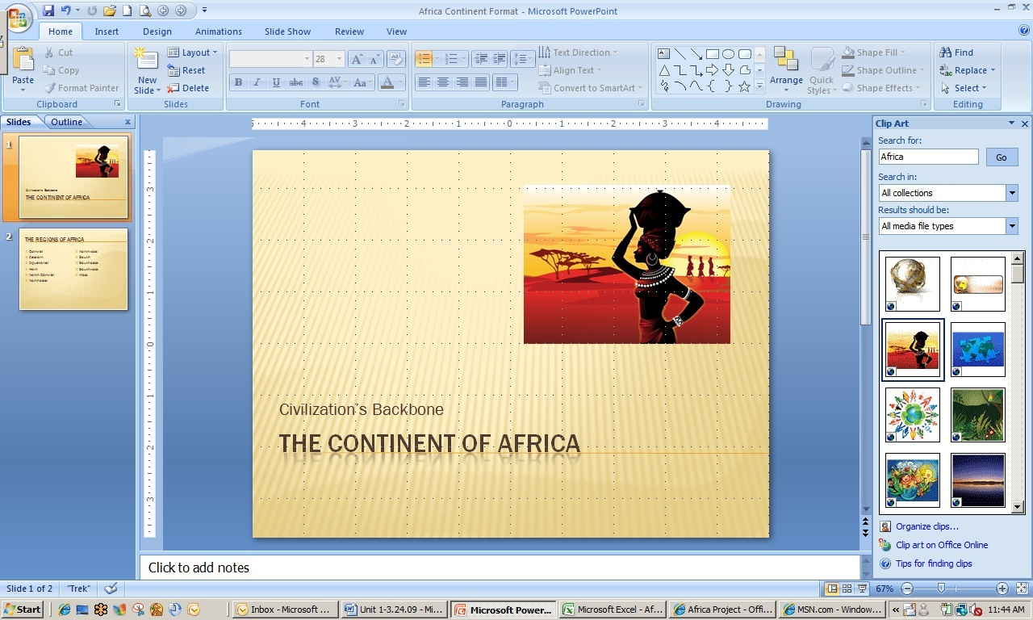Power Point: Theme Selection and Clip Art Placement

1. Save the document as *[Your Name] Africa Continent Format*. Close and then upload to your project workspace.
2. Remember to select and copy the document and then paste it to the general documents folder in your workspace so you can also share it with your partner.

Art students will continue to work on formatting and style, and will also contribute African art information as the presentation development proceeds.

Explore: Adding Slides and Content

The team member from Language Arts decided that an introductory slide is needed between the current slides 1 and 2. This slide will serve as an interest approach to the viewer and will also include a music clip contributed by the team’s music student who is anxious to begin work.

Communicating Using Office Live Comments

1. Open your Office Live project workspace and go to the **Africa Project Workspace**. Click Comment in the upper right corner to open the **Comment Pane**.
2. Type, Mary, add your introductory slide so I can select the music clip to go with it, in the box provided for the comment. Click Add comment.
3. Click Africa Project in the left navigation pane to return to the main project workspace. There should be a note in the right **Activity** pane that a comment has been added. If not, click Documents and then click Africa Project.
4. Team members who share the workspace will receive an e-mail indicating that a comment has been added.

Adding and Manipulating Content

1. Open the file, *Africa Continent Adding Slides.ppt*. Click slide 1 to select it.
2. In the **Home** tab**, Slides** section, click New Slide. A new slide with the same theme will appear between **slides 1** and **2**. Select the new slide 2.
3. In the **Home** tab**, Slides** section, click Layout and select Content with Caption from the drop down menu.
4. Place the cursor anywhere in the left text box and left click. Open the **Review** tab and go to the **Proofing** section. Click Research. Conduct a search for African Poem using Live Search as the reference site.
5. Open the first source (<http://www.poemhunter.com/poems/africa/>). Go to the second poem in the list, by Abisoye Sejoro. Click read more below the first four lines. Copy the poem and paste to the left text section of **slide 2**. Your slide will now resemble the one below.

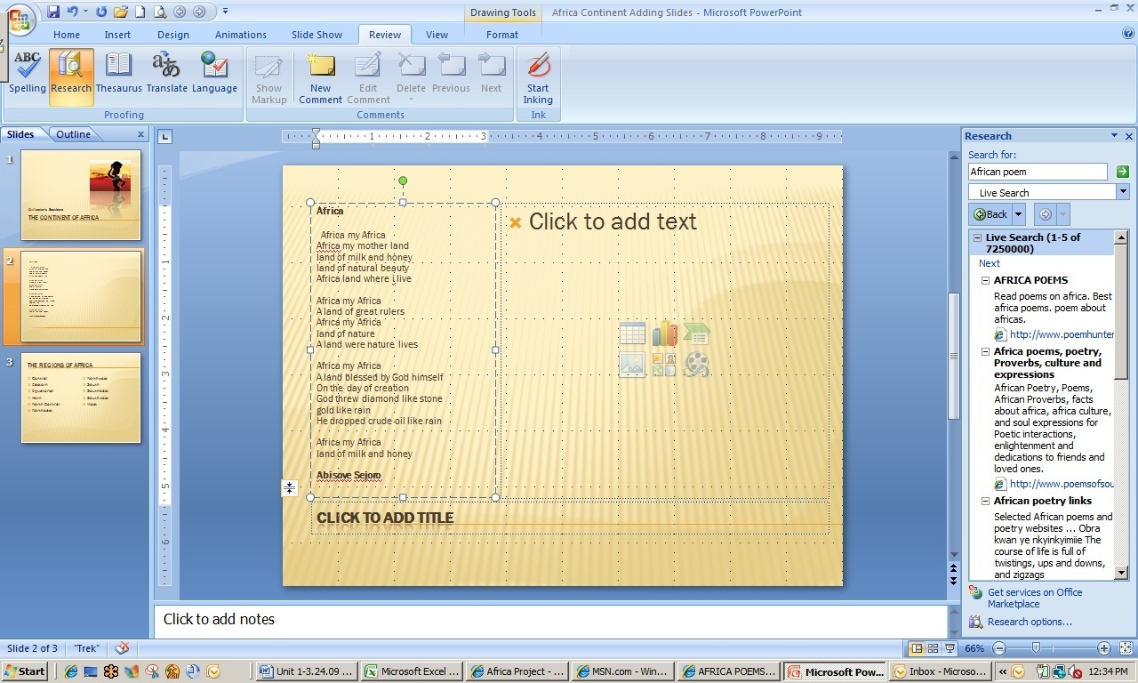

Power Point with Cut and Paste Addition

1. Place the cursor under the author’s name in the text box. Type <http://www.poemhunter.com/poems/africa/>. Highlight, right justify, and italicize the source.
2. The text of the poem is too small so an additional text box can be used to make the text larger. Reduce the size of the right side text box to about 2 inches wide.
3. Click anywhere in the left text box that contains the poem and then click on the outline so that a solid line appears. Type Ctrl C to copy the text box and its contents.
4. Place the cursor anywhere to the right of the text box, left click and then type Ctrl V. You may have to drag the text box to the right to place it in the center of the slide.
5. Move and resize the text boxes so that each occupies about one-third of the slide.
6. Delete the bottom two paragraphs and author’s name in the left text box. Delete the top two paragraphs and the poem title in the center text box.
7. In the **Home** tab**, Font** section, highlight and enlarge the poem text in both boxes to 20. Change the font of the poem’s title to size 36 and change the font color to a dark brown or rust.
8. 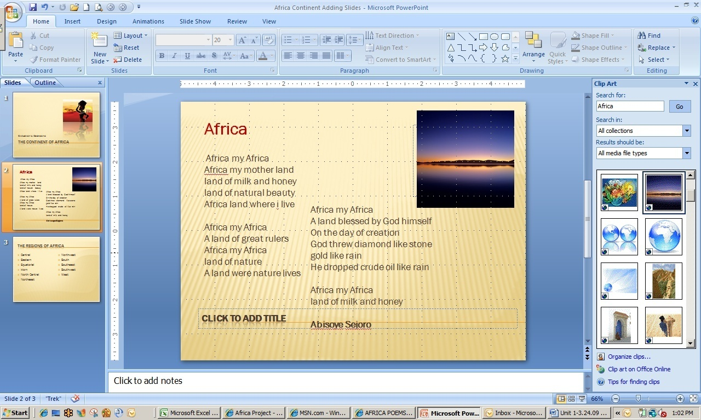In the remaining text box, find and click the Clip Art icon. Search the term Africa and select a clip art example that illustrates the poem. Click the graphic to place. Resize and move the graphic as necessary. The finished introductory slide should resemble the example below. The caption or title area will not appear in the slide show.

Power Point with Added and Resized Text Box(es) and Graphics

1. Save the file as *[Your Name] Africa Continent Adding Slides.ppt.* Close the file to upload to your Office Live project workspace and share with your (music) team member.

Explore: Adding an Audio Clip

After the slide deck containing the new introductory slide has been uploaded to the Office Live workspace, a comment can be added that will notify the music team member that activity has occurred. This most recent version can now be accessed by the music student for the addition of an audio clip that will enhance and emphasize the message of the poem that has been placed.

1. Open the file *[Your] Africa Continent Adding Slides.ppt.*. Click slide 2 to select it.
2. In the **Insert** tab**, Media Clips** section, click the arrow below the Sound icon and then select Sound from Clip Organizers from the drop down menu.
3. Type African music in the **Search for**: box. Scroll to find the sound clip titled, Kenya Trek, and select. When prompted, select When Clicked from the sound start options.
4. A small speaker will appear that you can move to a less noticeable place on the slide such as the lower right corner. Double click the Speaker icon to hear the selection.
5. Save the file as [Your Name] Africa Continent Music. Close.

Explore: Adding Animation

Team members decided to present information in the slide show by region. Now that the formatting has been done and an introductory slide created, the social studies team member is ready to add some general information to **slide 3** to introduce the viewer to the 11 regions of the African continent.

1. Open the file *Africa Continent Animation*. Click slide 3 to select it. Countries in each region have been added by the social studies team member using the team database.

**Note:** Indented lines have been created using the **Tab** feature.

1. Bold each of the region names and change their font color to dark brown or rust.
2. Click the title text box. Place the cursor at the end of the title and type and their countries. PowerPoint will automatically format what you type.
3. Click the left text box to select it. In the **Animations** tab**, Animations** section, click the arrow at the right of the **No Animate** box. Select Fade by 1st Level Paragraphs from the drop down menu. PowerPoint will preview the action for you.
4. Repeat this procedure for the right text box.

Custom Animations

1. Add a fourth slide. Select Content with Caption for the layout. Title the slide, Africa: Central Region.
2. Open the Internet Browser and go to [www.msn.com](http://www.msn.com). Type Africa central region in search box and select Images.
3. Right click the first picture and select Copy from the drop down menu. Leave the website open and return to the PowerPoint presentation.
4. Select either of the text boxes, clicking the outline until a solid line appears.
5. Type Ctrl V to copy the image to the slide. You will resize and move the picture after text has been added to the slide.
6. Open your Asia and Africa database and type 5-6 key pieces of information about the Congo in the left text box. Indent, as necessary.
7. Click the outline of the title text box until a sold line appears. In the **Animations** tab**, Animations** section, Click Custom Animation to access the **Custom Animation** pane.
8. Click Add Effect, Entrance, and then Dissolve In. Make sure that On Click is showing in the **Start:** box and that the **Speed**: is Medium.
9. Click the left text box outline until a solid line appears. Add an animation to the entrance of the text that will Fly In From Left. Have the animation appear on click at a medium speed.
10. Notice that the picture will be not animated. Click the Play icon below the **Custom Animation** pane. The picture will appear with the blank slide before the title or any of the other text.
11. Save the file as *[Your Name] Africa Continent Animation*. Close the file.

Explore: Adding Hyperlinks

The presentation is taking shape as students have decided what information to include on each slide. For regions that contain more than one country, students will have to be creative in how they synthesize information such as “type of government” for inclusion in the presentation.

The team has decided to create two slides per region, one with important demographic and social information and one with cultural information. A hyperlink to another document or slide can be inserted in cases where additional information should be displayed.

1. Open the file *Africa Continent Hyperlink.ppt*. The graphic placed on **slide 4** has been enlarged and is distorted, so it will have to be replaced. Select the graphic and type Del. .
2. Insert a picture from your student files, Slide 4 Congo Picture. Resize and move as necessary.
3. Add a 5th slide. Select Comparison layout. Type Art & Music of the Central Region in the title box. In the top left text box, type Art; in the right text box, type Music. Center and bold the headings.
4. Scroll over the insertion options in the lower left text box and select Insert Picture from File. Locate your student files and insert Slide 5 Congo Mask. Your screen should resemble the one below.

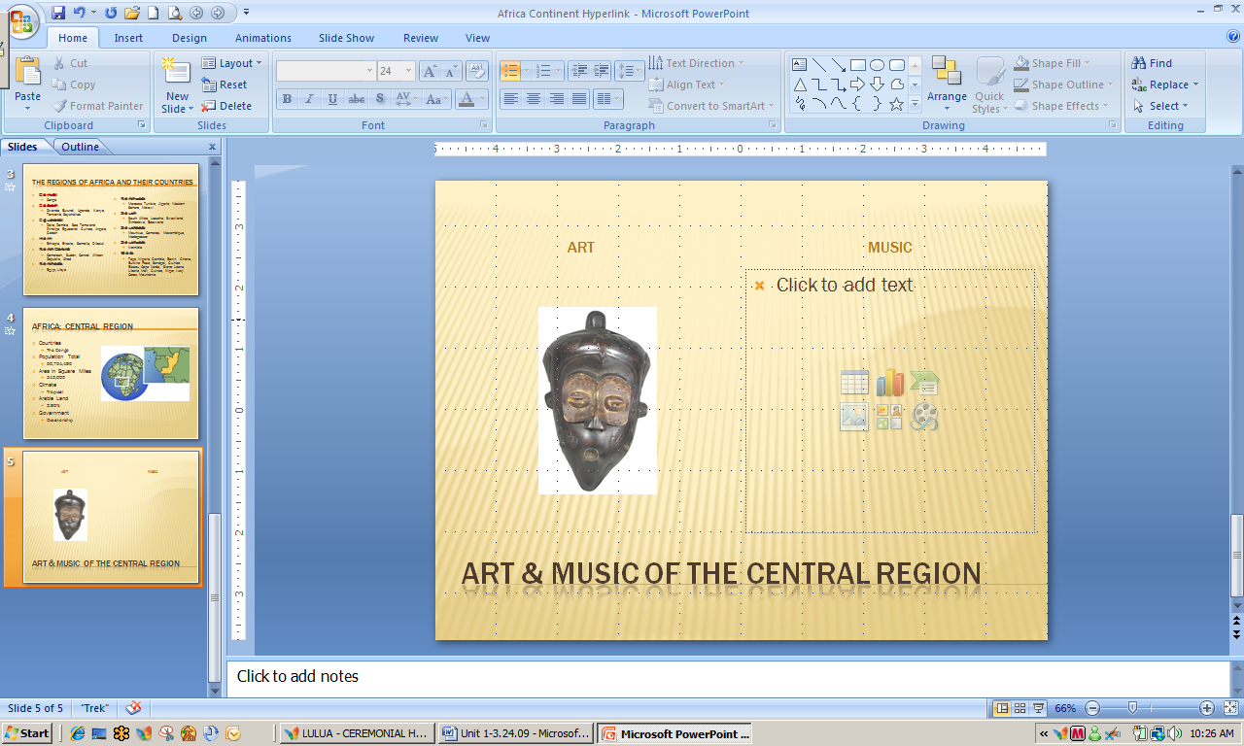PowerPoint Comparison Layout with Inserted Picture

1. In the **Insert** tab**, Text** section, click Text Box. Place the cursor below the graphic, left click and draw a text box approximately 2 inches x ½ inch. Type Lulua Tribal Mask in the text box. Center the text.
2. Highlight the text. In the **Insert** tab, **Links** section, click Hyperlink. The **Insert Hyperlink** dialog box will appear. The following information should be entered (See completed dialog box):

* **Text to display**: Lulua Tribal Mask
* **Link to**: Existing File or Web Page
* **Look in**: Student Files (this will be your set of student files for this session)
* Current Folder (will be highlighted)

1. Select the file Lulua Mask Hyperlink. The file location will appear in the **Address:** box.

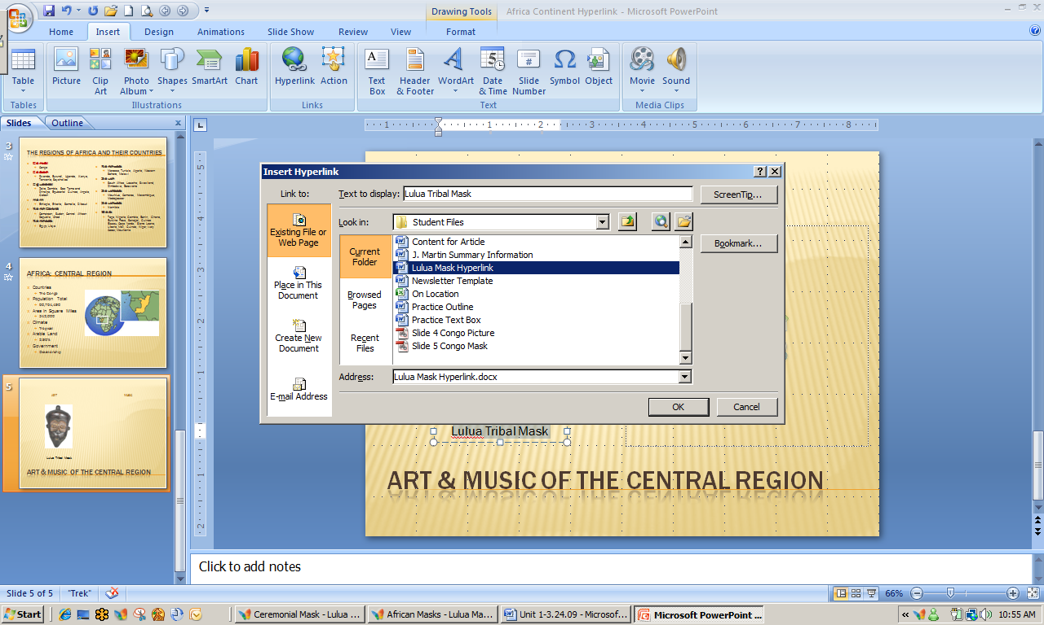

Insert Hyperlink Dialog Box

1. Save the file as [Your Name] Africa Continent Hyperlink. Close.

Hyperlinks to a Web Page

You are ready to work on the Eastern Region slides and, since there is more than one country, you will have to be creative to place sufficient information on just two slides.

1. Open the file *Africa Continent Weblink*.*ppt.* Go to **slide 6**.
2. Insert the picture Map of Eastern Africa Link in the right text box (from your student files).
3. Create a text box below the map and type Click Here for More Information.
4. Highlight the text in the box. Insert a hyperlink. In the **Insert Hyperlink** dialog box, **Address** section (at the bottom of the box), type <http://msp.sfsu.edu/intensive/cabaya/sites/AfricanCultural/africa/1_4east.html>

http://msp.sfsu.edu/intensive/cabaya/sites/AfricanCultural/africa/1_4east.html

1. Click OK.
2. Resize and move the picture as needed.
3. Click the outline of the hyperlink textbox until it is solid. Animate it so that it is placed on the slide after the other text.

**Note:** The default action for animation is to insert after the previously placed object.

1. Save as *[Your Name] Africa Continent Weblink*. Close.

Test Your Knowledge

The tasks below were addressed in this unit. Be sure you understand the terms used and are able to complete the tasks listed.

Review Me – Selecting Themes and Adding Slides (PPt)

1. Open MS PowerPoint 2007. Open the database file, Water Quality Indicators, located in your Student files. Review the data sheet, Indicators, to note the content. Select the theme, Flow, from available PPT themes (Design tab, Themes section).
2. Place the title, Water Quality Indicators, in the title box on slide 1. Add your name as a subtitle.
3. Add a slide between slides 1 and 2 and keep or select the Title and Content layout in the new slide. Type the title, Sites Tested in the title box. Leave all files open for next activity.

Review Me – Adding Content Slides

1. Click Insert Table in the slide 2 text box. Create a slide with 2 columns and 6 rows. Change the table style (Table Tools, Design tab) to Light Style 1 – Accent 3.
2. Copy and paste Table 2 from the datasheet, Sites, of your water quality database into the table.
3. Enlarge the font of the table on slide 2 to Arial 24. Move the table so it is not so close to the title box, if necessary.

Review Me – Adding Text and Graphics

1. Change slide 3 layout to Two Content. Title the slide, Testing Results. Add a subtitle to the left text box, Temperature vs. Dissolved Oxygen.
2. Add 3-4 bulleted points about the relationship between temperature and dissolved oxygen based on information in datasheet, Temp and Oxy. These could be any points of information, e.g. Colorado site had the lowest temperature at time measurements were recorded.
3. **Note**: Remember to indent your bulleted points.
4. Copy and paste the chart from the datasheet, *Temp and Oxy*, to the right text box. Resize or move the chart as necessary. Animate the slide so the bulleted points enter after it is opened. Close all files.

Curriculum Connections

Students use computers in the classroom as a tool for both productivity and learning. Integrating computer skills with the academic curriculum motivates and engages students, and prepares them for the technology age. Below are a few ideas which can be used to integrate the skills covered in this unit into the academic curriculum.

Idea 1 – Synthesizing Information

* Student teams create presentations at the end of project activities, a unit of instruction, or grading period to force their synthesis and analysis of information and key points.
  + PowerPoint displays of data tables and charts enhance discussions and enable students to better see connections and relationships.
* Students create PowerPoint presentations as one form of a digital portfolio of their work, particularly when focused on a unique standard or competency.

Idea 2 –Engaging Multiple Intelligences

* All students contribute to a PowerPoint creation by tapping into their unique interests and abilities. This concept is particularly evidenced when teamwork involves students in multidisciplinary settings.
* A presentation can be extremely sophisticated or very simple. Even the most challenged students can use PowerPoint to express themselves in ways they are most comfortable and confident, thereby contributing to the group process.

Idea 3 – Variety in Presentation to Individualize Instruction

* Educators use PowerPoint to present content in a variety of modes, reaching students of varied learning styles. Open class with a “global or big picture” view of the content (e.g. the solar system) and narrow to a discussion of more detail, such as location of planet Earth in the system.
  + The homework assignment for this lesson utilizes a 2-3 slide PowerPoint, accessed via the class website and using the opposite sequence (very detailed to more global data).
* Synthesis of key points to a PowerPoint presentation as well as the colors, graphics, and varying layouts, aid students with reading, auditory, vision, and attention deficit difficulties.

Use the space below to write down additional curriculum connections ideas:

|  |
| --- |
|  |
|  |
|  |
|  |
|  |
|  |
|  |
|  |
|  |
|  |
|  |
|  |
|  |
|  |
|  |
|  |
|  |
|  |
|  |
|  |

Unit 4: 21st Century Tools to Aid Collaboration

Unit Objectives

Create and Navigate a digital notebook using MS Office One Note 2007®.

Edit documents stored in One Note using the Tablet PC and its tools.

Create a Live Mesh® and desktop folders. Access and share documents using Live Mesh.

21st Century Tools to Aid Collaboration

So, you consider yourself to be a 21st century teacher or learner! How many times have you or your students **forgotten to e-mail a document** or put it on the flash drive, leaving for work or school and realizing—too late—that it is not available when you need it? An “**anytime, anywhere learning attitude**” requires use of multiple types of hardware—PCs, tablet PCs, smart phones, etc., and a means to **synchronize work** between them.

Microsoft® has tools available to allow learners to collaborate on projects from several locations, not just using the school network. You have already experienced the usefulness of MS Office Live to share documents and document versions. Now you will look at a few tools that enable you to collaborate across locations, access multiple media and documents, and provide controlled access to others more efficiently.

MS Office 2007 One Note

MS Office One Note 2007 is a **digital “three-ring binder”** that enables individuals and team members to manage project, personal, and business information. Any student project can be organized more efficiently because, unlike paper-based systems, One Note provides a “storage place” for text, pictures, digital handwriting, audio and video recordings, and much more. As with other Office products, One Note has readily available templates to make the organizing easier, with a set of collaborative tools to help teams work together, both offline and online.

MS Live Mesh

MS Live Mesh **connects you, seamlessly**, to the people, devices, programs, and information that you care about—wherever you happen to be. **YOU create your mesh**, adding devices, specifying what information is available and to whom, and synchronizing your network so that the most up-to-date versions are available at all times.

The best feature of Live Mesh is that you can **connect to your remote computer** and then use it as if you are sitting right in front of it! Once you access, edit, or do whatever work is required on the remote computer, you can copy and paste files between your local computer and your remote computer as necessary. MS Live Mesh puts YOU at the center of your digital world!

MS Live Mesh Connecting Several Computers

The Integrated Lesson

The following lesson was written by Mr. Jonathan Kidman, the English teacher who taught the collaborative writing lessons in Unit 1. Mr. Kidman plans to involve his students in another collaborative writing activity, this time writing poems. Students learned the basics of, “What is poetry?” in the previous lesson and will now write poems in several styles. The product of the collaborative project will be a book of poems about the continent Africa to be illustrated by the art classes.

In this lesson, students begin with the letters A

F

R

I

C

A

and with access to all their resources from the Africa project. Each line of the six-line poems will begin with A, then F, R, I, C, and finally A. They will be working in 2-3 member teams, rotating through the team to write each line and using One Note and Live Mesh as they work on their projects.

Integration Project Lesson Plan

| KNS  For Standards-based, Student-centered, Technology-rich Learning | Teacher: | Mr. Jonathan Kidman |
| --- | --- | --- |
| School/District: | Homestead Middle School |
| Subject Area(s) Addressed: | Language Arts |
| Grade Level(s)/Course: | 6th - 8th |
| Date Submitted: | July 1, 2009 |
| Lesson Duration: | 1 50-minute period |

|  |  |  |
| --- | --- | --- |
| Unit Title | Experiencing Africa | |
| Lesson Title | Thinking as a Poet | |
| General Lesson  Outcomes | In the previous lesson, students read and learned about many types of poetry. They are now going to spend some time working within a team to develop poems that contain content about the African continent. | |
| **Academic Standards Addressed** | NCTE/IRA National Standards for the Language Arts (http://www.ncte.org/standards)   1. Students adjust their use of spoken, written, and visual language (e.g., conventions, style, vocabulary) to communicate effectively with a variety of audiences and for different purposes. 2. Students employ a wide range of strategies as they write and use different writing process elements appropriately to communicate with different audiences for a variety of purposes. 3. Students use a variety of technological and information resources (e.g., libraries, databases, computer networks, video) to gather and synthesize information and to create and communicate knowledge. 4. Students develop an understanding of and respect for diversity in language use, patterns, and dialects across cultures, ethnic groups, geographic regions, and social roles. | |
| **Technology Standards Addressed** | Technology Standards (NETS – http://www.iste.org)   1. Creativity and Innovation.   Students demonstrate creative thinking, construct knowledge, and develop innovative products and processes using technology. Students:  a. apply existing knowledge to generate new ideas, products, or processes.  b. create original works as a means of personal or group expression.  2. Communication and Collaboration  Students use digital media and environments to communicate and work collaboratively, including at a distance, to support individual learning and contribute to the learning of others. Students:  a. interact, collaborate, and publish with peers, experts, or others employing a variety of digital environments and media.  b. communicate information and ideas effectively to multiple audiences using a variety of media and formats.  d. contribute to project teams to produce original works or solve problems.  3. Research and Information Fluency  Students apply digital tools to gather, evaluate, and use information. Students:  plan strategies to guide inquiry.  a. locate, organize, analyze, evaluate, synthesize, and ethically use information from a variety of sources and media.  c. evaluate and select information sources and digital tools based on the appropriateness to specific tasks.  d. process data and report results.  4. Critical Thinking, Problem Solving, and Decision Making  Students use critical thinking skills to plan and conduct research, manage projects, solve problems, and make informed decisions using appropriate digital tools and resources. Students:  b. plan and manage activities to develop a solution or complete a project.  c. collect and analyze data to identify solutions and/or make informed decisions.  5. Digital Citizenship  Students understand human, cultural, and societal issues related to technology and practice legal and ethical behavior. Students:  a. advocate and practice safe, legal, and responsible use of information and technology.  b. exhibit a positive attitude toward using technology that supports collaboration, learning, and productivity.  c. demonstrate personal responsibility for lifelong learning.  d. exhibit leadership for digital citizenship.  6. Technology Operations and Concepts  Students demonstrate a sound understanding of technology concepts, systems, and operations. Students:  a. understand and use technology systems.  b. select and use applications effectively and productively.  d. transfer current knowledge to learning of new technologies. | |
| **Teacher-Led Activities** | 1. Review content from previous day on types of poems. 2. Describe project and provide students with project website where they can access full instructions, links, documents, etc. 3. Handout instruction sheet for cooperative group work. 4. Divide students into groups of 2-3 by having them match poems to authors (written on index cards handed out as they enter room). 5. Monitor and assist students as needed. 6. Collect poems . | |
| **Student-Centered  Activities** | 1. Make notes, as needed, on project instructions. 2. Access Excel databases with information on African continent and Power Point presentation. 3. Open Africa project workspace to access all content documents. 4. Using letters of A, F, R, I, C, and A as first letters of a six-line poem, write a poem using content about Africa. Team members will rotate authorship of the lines, with each member completing 2-3 lines depending on the size of the group. All information provided should accurately reflect content. 5. Conduct Internet research to locate clip art or other graphics to illustrate the poem. 6. Revise the font size, font type, color, shape, etc. to enhance the appearance of the poem and also match its theme, if possible. | |
| **Resources Needed** | Content resources (books, articles, speakers, handouts, materials, etc.) | Software/Web Resources (CD-ROMs,URLs, etc.) |
| * Handout - Project instruction worksheets. * Handout - Activity worksheets. * Excel databases containing African continent content. |  |
| Hardware (computers, TV, DVD, etc.) | Other media, video, satellite, etc. |
| Computer lab with minimum 25 computers or mobile lab with individual laptops. |  |
| **Student Assessment Strategy** | * Formative assessment as students work on assignment. * Evaluation of lesson activity. * Responses to related questions on unit test. * Evaluation of final project. | |

Explore: Using One Note for Collaborative Projects

Your students worked hard to complete the individual team projects. Art students are nearly finished with their tribal ceremonial masks. The thumb pianos work remarkably well and students are beginning to compose original music for them. Cafeteria workers announced they are planning to cook some authentic African food the day of the open house. The teams have decided to ask the art and language arts members to do a formative assessment and edit of the first few slides of their presentations before anymore work is done on them.

Windows Vista

1. Click StartMenuButton and open Microsoft Office One Note 2007®. If One Note does not show up on the **Start** menu, click All Programs, Microsoft Office, and select Office One Note 2007. You can also type One Note in the search box.
2. Find the **New** tab in the upper left corner of the notebook. Using the arrow to the right, click and select Notebook from the drop down menu. The **New Notebook Wizard** will appear.
3. Title the new notebook, Africa Team Project, and select Shared Notebook – Group Project from the **Template:** menu.
4. On the next wizard dialog box, select Multiple people will share the notebook and then On a Server. Click Next.
5. Click Browse to the right of the **Path:** box to access the **One Note Notebooks** folder. Click Select in the lower right corner of the dialog box.
6. Make certain that the box is checked to create an e-mail inviting team members to access the notebook.
7. Click Create to confirm the location of your stored One Note notebook.
8. An e-mail should appear with instructions to open the notebook. Send the e-mail to your partner. Leave OneNote open.

Adding Documents and Other Resources to Your Notebook

1. The first seven slides, covering the Central and Eastern regions have been completed and are ready for review.
2. Open the file Africa Continent One Note Edit. Ppt.
3. Click the Office button and then click Print. In the **Print Dialog** box, go to the **Printer** section and scroll to find/select Send to One Note in the **Name:** box.

**Note:** If Send to One Note does not appear as a printer selection, your instructor will help you to install the printer driver.

1. Click OK. The screen should appear similar to the one below.

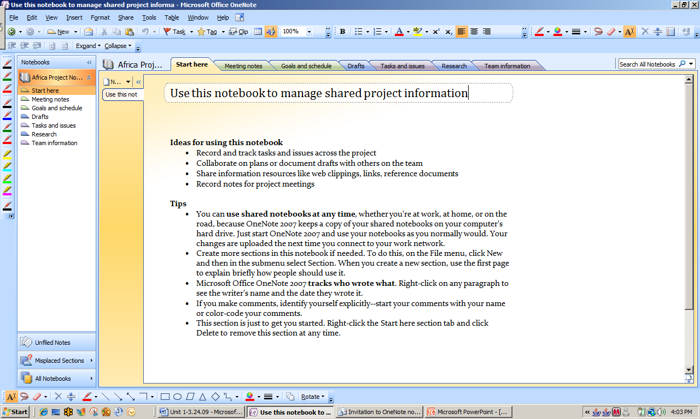

One Note Project

1. Go to the lower left and click Unfiled Notes. The presentation should appear, embedded in a set of “notebook pages.”
2. Right click the Untitled page tab to the left of the first page. Select Move Page to Another Section.
3. Select Drafts from the **Move Pages to**: list and click Move.
4. Click Drafts in the left navigation pane. Click Untitled page to open the presentation. The cursor will be blinking in a title box at the top left. Type PPT Draft 1. Note that the title now appears on the tab to the left.
5. Click the Office button and then select Save As. A dialog box will automatically open that will save the document as a draft in the One Note Notebooks folder on your hard drive. Make sure Current Section is selected and click Save.

Editing in One Note

Editing in One Note is easy because you can use any of the tools available to you with a Tablet PC. Your team editors will be able to make hand-written notes, type notes, insert pictures and sound, add hyperlinks, or other types of notations. Because the work is handled digitally, team members can view everything in full color, access the Internet and other files easily while working, and save paper.

**Note:** If you do not have a Tablet PC, most of your edits can be made by typing notes into text boxes.

1. If necessary, open MS Office One Note 2007. Your project folder will automatically open, as well. Open the **Drafts** section.
2. Place the cursor anywhere on **slide 1** and type Sound should be added as an introduction. Also make a note that there are sound files available in the project stored files. Make the following edits on slides 2 through 7:
3. **Slide 2**: Using the tablet pen, make notes to left-justify the title and the first line of the poem. Also ask what sound file is being used.
4. **Slide 3**: The slide needs a graphic. Place the cursor anywhere in the bottom left of the slide. Click Insert in the top task bar and select Hyperlink. Browse and select the file titled Tree in a folder of pictures and sounds for the Power Point located in your Student Files folder. Click OK.

In the **Text to display**: box of the **Hyperlink** dialog box, replace tree with Insert this picture from our stored files somewhere on this slide.

Go back to **slide 3**, click on the hyperlink and observe what happens.

The font size on this slide is too small. Experiment with different font sizes and make a suggestion.

1. **Slide 4**: The map on **slide 4** is not of the central region and needs to be replaced. The student files, picture/sounds folder, contains a picture of a coffee plantation that would enhance this slide. Suggest in some way that it be added.
2. **Slide 5**: The art depicted on **slide 5** is historic, traditional Congolese art, while the description of the music is from more contemporary times. Make notes of this. Click the New Page icon at the top left of the section. Notice that a new page appears below PPT Draft 1. Direct students to this page.

Click Insert, select Pictures, and then From Files. You should be automatically directed to the special picture/sounds folder in the student files. If not, go to that folder and select the picture Central Africa Tam Tam. Click Open. The picture will be inserted in the new page.

Type a note by the picture directing students to research the Tam Tam, place the picture in the slide with a title, and add music (there is a Drum sound in the stored files).

1. **Slide 6:** A map and graphics should be added.
2. **Slide 7:** There are misspelled words. Someone saved a picture of a thumb piano to the stored files. Also, music students have actually made models of thumb pianos in class. How can those be incorporated into the PowerPoint presentation? Sound should be added.
3. Save the file as, *[Your Name] Africa Continent One Note Edit* and close.

Setting Up a Live Mesh Network

Setting up a Live Mesh® network is easy! You will be able to use the same Windows Live ID that you used to set up and access your Office Live workspace.

1. Go to the website <https://www.mesh.com/Welcome/default.aspx>. A welcome page will appear.
2. Click Sign In, read the agreement on the following page, and then click I agree. The next page shows hypothetical devices that you could add to your mesh, as well as the **Live Mesh Live Desktop** that is always accessible. Go to the right side of the mesh and click the large orange plus sign. The mesh rotates so that the plus sign is in the center.
3. Select your system in the **For:** box and click Install. Select Run in each of the next two dialog boxes that appear.
4. Follow instructions for installation of software if it is not currently installed on your machine and for signing in. Ask your instructor for assistance, if necessary.
5. Live Mesh Wire should be installed on your machine and you should now be ready to set up folders for sharing.

Explore: Navigating the Live Mesh Website

When you are logged in to Live Mesh, you can choose to view three different windows:

* Desktop. The Desktop is very similar to the desktop on your laptop or PC in that it shows files and folders available for your easy access. Click Desktop in the taskbar at the top of the screen. There should be only one folder on your desktop, one titled *Create new folder*.
* Devices. This screen shows all the machines that have been added to your mesh. You can connect with any of these. Currently, your devices should include the Live Desktop and the machine on which you are presently working. Click Devices to see what machines are included on your mesh.
* News. The news screen provides you with a list of recent activity to the Live Mesh site.

1. Click News. The creation of your mesh should be listed.
2. Leave Live Mesh open for the next activity. The Devices screen should appear similar to the one below.
3. Note the smaller navigation pane in the lower right corner, which appears if you click the Live Mesh icon in the lower right task bar.

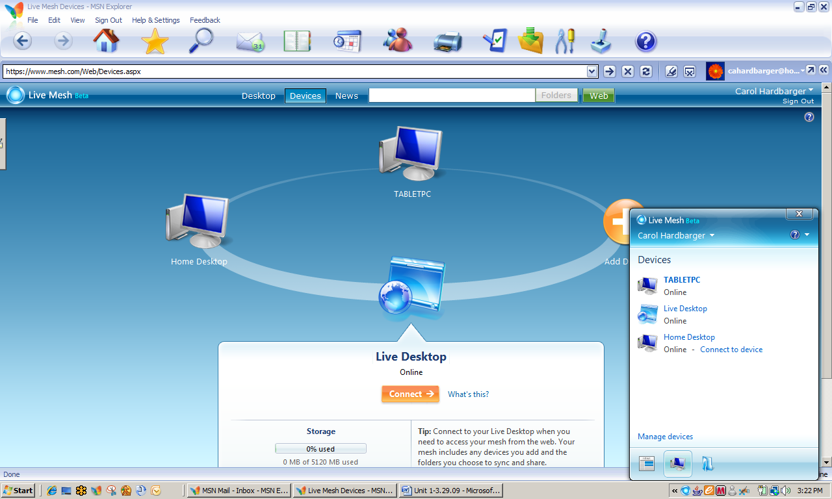Live Mesh Devices Screen

Creating a Folder for Your Project Work

If you know you will be using multiple computers for various assignments, installing and using Live Mesh ensures that your work will always be available. The advantage of using Live Mesh over a storage site such as Office Live is that you can access the most recent document or version available. For example, a document that was revised at home and stored on the home computer can be accessed by using Live Mesh, even if it was not placed in the Live Mesh desktop folders.

1. If necessary, open and sign in to Live Mesh. Click Desktop to access the Desktop screen.
2. Double click Create new folder to open the **New Folder** dialog box. In the **Name:** box, type [Your Name] Africa Newsletter.
3. Click Show synchronization options. Make certain that When files are modified or added is selected for each device. Click OK. The folder now appears on your Live Desktop.
4. Double click to open the folder. A folder navigation pane and a news pane will appear that are similar to the ones below.
5. Leave Live Mesh and the navigation pane open for the next activity.

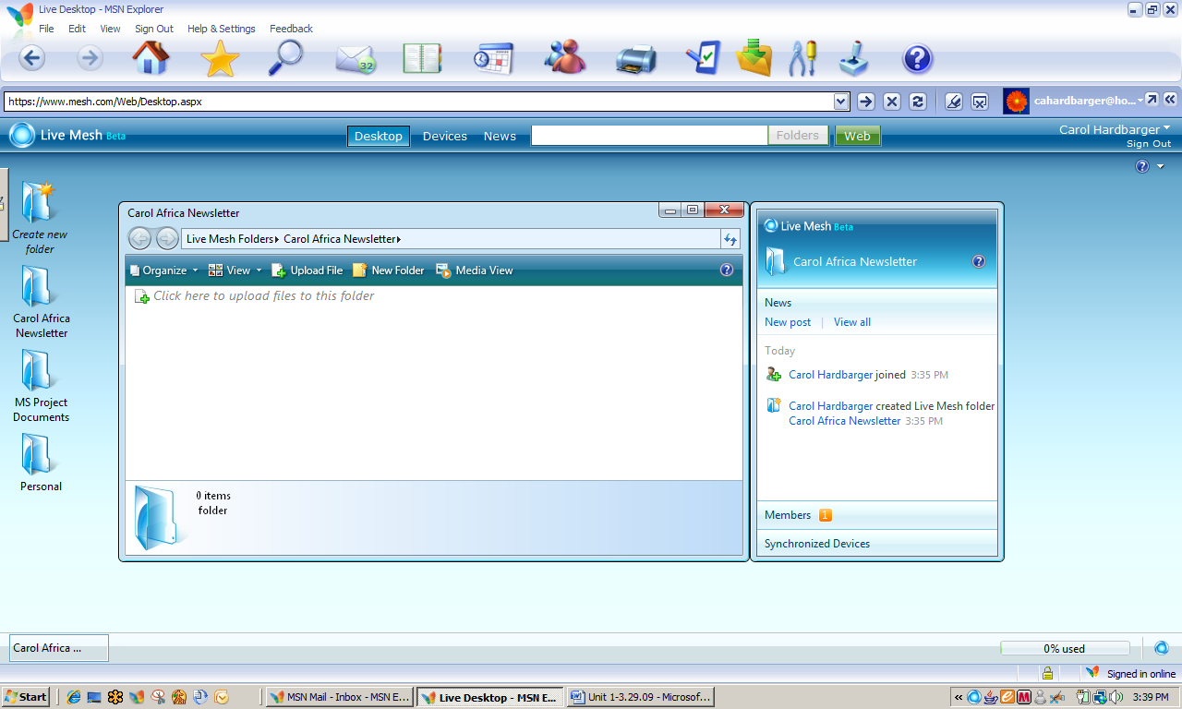

Live Mesh Folder Navigation Pane

Uploading Files to a Live Mesh Desktop Folder

1. Once you have created desktop folders on Live Mesh, it is easy to upload files. If necessary, open Live Mesh and **[**Your] Africa Project Newsletter folder.
2. In the folder navigation pane, click Click here to upload files to this folder.
3. Select the PowerPoint presentation, *Africa Continent Final* and then click Open. The presentation file has now been added to your Live Mesh desktop.
4. Leave both the folder navigation pane and Live Mesh open for the next activity.

Sharing Live Mesh Desktops and Folders

You can provide access to any of your desktop folders to any individual or group of individuals you wish, but, just as with Office Live you must invite them.

1. If necessary, open Live Mesh and the Africa project folder. In the news pane, click Members and then Invite. The **Invite Members** dialog box will appear.
2. Invite your partner from Unit 1 and one additional person from this class, typing their e-mail addresses – separated by a semicolon – in the **Members:** box. In the **Permissions:** box, select Contributor. Click OK.
3. Close the folder navigation pane and leave Live Mesh Open.

**Note**: In order to access a remote desktop, the Sleep or Hibernation feature of the remote device must be disabled.

Explore: Accessing a Shared File on a Remote Desktop

“But, Mrs. Smith, I did my homework, but I left it on my computer at home!” Have you ever heard that? In fact, most of us have heard or said something like that at one time or another. In this activity, you will access your partner’s desktop to open a document for review, to edit, and then save.

1. If necessary, log on to Live Mesh. Make certain that the file, *[Your] Africa Continent One Note Edit*, has been added to your Live Mesh project folder on your desktop.
2. You should have received an e-mail from your partner inviting you to share a folder with Live Mesh. Open that e-mail.
3. Click Click here to view the invitation, which will take you to the following screen.

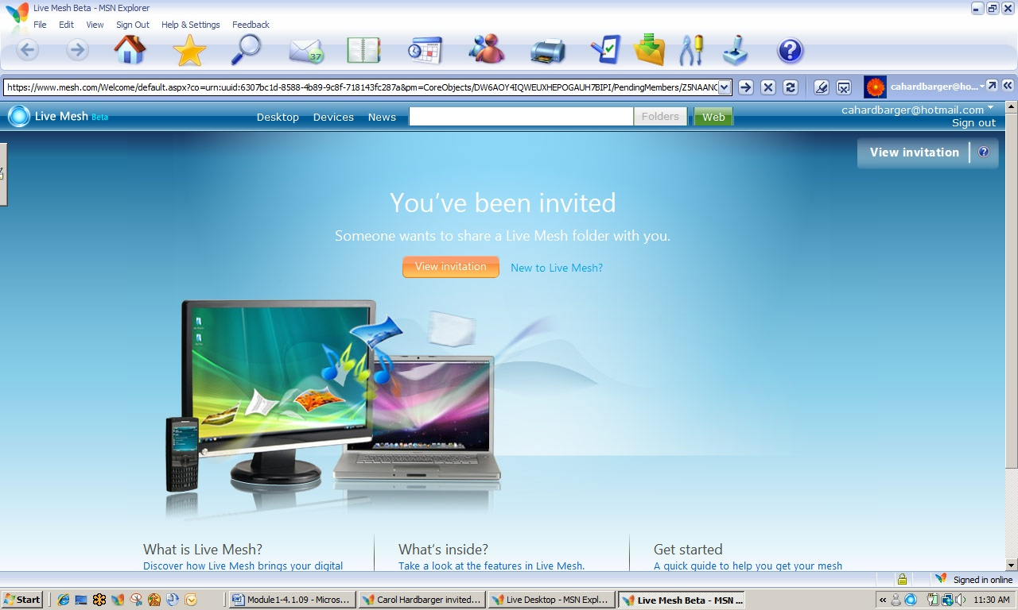

Live Mesh Invitation Screen

1. At the next screen, click Accept Invitation. You will be immediately directed to the desktop location of your partner’s shared file.

**Note**: You are actually accessing a file stored on a desktop, not on a website.

1. Double click the file to open or save it. Select Save this file now and then click OK. Keep the same name and save the file to your student files.
2. Close any open files and close Live Mesh.

Test Your Knowledge

The tasks below were addressed in this unit. Be sure you understand the terms used and are able to complete the tasks listed.

Review Me – Creating a Notebook in One Note

1. Open MS Office One Note 2007®. Create a new Student Semester Notebook named [Your Name] Semester Notebook that you will use on multiple computers. Store the notebook in the Documents, One Note folders (Default).
2. Delete the **Start Here** tab. Rename Class A, Chemistry. Delete the About This Section page. Leave the file open for the next activity.

Review Me – Navigating in and Adding Content to a Notebook

1. Go to the website, <http://spiepho.sbc.edu/worksheets/Gen_Chem_1/Chp2,naming.html>. Print (Send to) One Note. The page opens in the **Unfiled Notes** section.
2. Name the page, Naming Cmpds. Move the page to the **Chemistry** class tab.
3. Activate pen feature on your tablet. For Exercise 1, #3, write *NH4+*in the empty box by ammonium ion. For Exercise 2, #19, write *ammonia*.
4. Place the cursor anywhere on the page. Insert a hyperlink to <http://www.sciencegeek.net/tables/tables.shtml> and title it Periodic Table. Leave the file open for the next activity.

Review Me – Using Templates in One Note

1. Click Format and then Templates. Add Math/Science class notes from the Academic section. Place today’s date in the title box.
2. In the **Homework** box, type Review PowerPoints. Insert, Files. , Periodic Table (a PPT file located in your Student Files). A PPT icon should appear that links to the file.

Review Me – Using Live Mesh

1. Open Live Mesh and create a desktop folder to store your Chemistry Notebook. Add the notebook to the folder.

Curriculum Connections

Students use computers in the classroom as a tool for both productivity and learning. Integrating computer skills with the academic curriculum motivates and engages students, and prepares them for the technology age. Below are a few ideas which can be used to integrate the skills covered in this unit into the academic curriculum.

Idea 1 – Keeping Track of Resources

* Science students investigate the role of light in plant growth. Using MS Office® tools including One Note, they develop a shared task list, conduct and keep track of individual research, notes, and links, and collaborate on written and oral presentations.
  + Documents are shared, but also stored on Live Mesh so that work can be done in remote locations.
  + Notebooks can be organized by team member, task, or product.

Idea 2 – Creating a Paperless Environment

* A math teacher discovers worksheets on the Internet that are perfect to introduce some new material. She “prints” them to One Note and uses with her Tablet PC in class. Students follow along with the discussion, using a One-Note lecture template.
  + The teacher uses One Note to distribute a downloaded problem sheet to students who work together in cooperative groups to discuss and solve.
  + Instead of submitting a paper notebook for grading at the end of the marking period, students submit a One Note notebook, divided into sections by units covered during the marking period.
  + Using Live Mesh ensures that the latest version of any assignment is available when needed.
* The 6th grade science teacher at Homestead Middle School works one-half day in two different locations. He has created a mesh that includes the desktop computers in each of his two work locations, his home desktop, and his laptop. There is never an inconvenience caused by last-minute interruptions or other circumstances that prevent e-mailing documents, downloading them to a flash drive, or printing out hard copies.

Idea 3 – The Iterative Process

* Sally Quinn, a language arts teacher, finds that One Note encourages more reflective thinking on the part of her students because of the interactive research features. The ability to access the Internet and immediately record results—while reviewing assigned work, lecture notes, reading, or working on a project—helps students see a broader picture than the initial notes.
* One Note provides a perfect tool for portfolios that are designed to illustrate student learning progress. For example, science students can show increasing sophistication in understanding scientific inquiry by including their project and laboratory notes and observation write-ups.

Use the space below to write down additional curriculum connections ideas:

|  |
| --- |
|  |
|  |
|  |
|  |
|  |
|  |
|  |
|  |
|  |
|  |
|  |
|  |
|  |
|  |
|  |
|  |
|  |
|  |
|  |
|  |

Unit 5: Tying It All Together

Unit Objectives

Identify academic and social benefits specific to Experience Africa project.

Identify additional project uses for MS Office and other Microsoft applications.

Identify potential content areas to include in a multidisciplinary gardening project.

Match MS Office and other Microsoft applications to multidisciplinary gardening project activities.

Tying It All Together

You can breathe a sigh of relief! The poster displays are set up in the cafeteria and the team PowerPoint presentations to accompany each display are up and running. The “Tribal Art Museum” and audio accompaniment are nearly assembled and a few parents are already waiting in the lobby to attend the open house.

Mr. Kidman’s 7th grade English class has worked with the business communications students to create the program for the open house. The booklet also contains the Africa poems written by English students and illustrated by art students. A digital photo of one of the art student’s tribal masks illustrates the cover of the program and a map of Africa created by a group of social studies students is on the back.

A “buzz is in the air” and it is not from tse tse flies!

The Benefits of Project Based Learning

As an educator, you increasingly work with students of diverse backgrounds, cultures, native languages, and ability levels. Project based learning is one way to provide a greater range of learning opportunities to your classroom. Working on a project with others motivates learners by allowing them to work with content in the context of real-world situations (Katz & Chard, 1989). Additionally, twenty years of research has shown that motivation has a positive impact on achievement (Brewster & Fager, 2000).

Particular benefits of project based learning include

* Preparing children for the workplace.
* Increasing motivation.
* Connecting learning at school with reality.
* Providing collaborative opportunities to construct knowledge.
* Increasing social and communication skills.
* Increasing problem solving skills.
* Enabling students to make and see connections between disciplines.
* Providing opportunities for children to contribute to their school or community.
* Increasing self-esteem.
* Allowing children to use their individual learning strengths and diverse approaches to learning.
* Providing a practical, real world way to learn technology. (Northwest Regional Educational Library, 2002)

Possibilities for projects are endless—the key for successful project implementation is that it be challenging, student-driven, and meaningful.

Explore: Thinking about the Benefits of Project Based Learning

Think about the multi-disciplinary Africa Experience Project with which you worked and ways that it would benefit educators and students.

1. Using the information above, list at least three ways that the Africa project would benefit students. An example has been provided.

|  |  |
| --- | --- |
| Benefit | How It Benefits |
| Children use individual learning strengths. | Art students learned about history, culture, and current issues of Africa through 1) researching and making tribal masks and 2) designing and editing PowerPoint presentations. |
|  |  |
|  |  |
|  |  |
|  |  |

MS Tools to Aid Project Based Learning

You have explored a variety of MS Office and other Microsoft tools that can greatly enhance students’ experiences with project based learning.

Explore: Selecting the Right Tool for the Job

Following is a list of Microsoft tools used with the Africa Experience Project. Project activities you completed were within the framework of student assignments, but only reflected one or a few potential uses of the applications involved.

1. For each of the listed PC- or web-based applications, identify at least one additional use by teachers or students for completion of a project.

* MS Office Excel 2007.
* MS Office One Note 2007.
* MS Office Word 2007.
* MS Office PowerPoint 2007.
* Live Mesh.

Designing a Project Based Unit

As you have seen, project based learning can be used with student teams in a single classroom, across several classrooms in the same content area, or in multidisciplinary classroom settings. Planning is an extremely important aspect of facilitating successful projects:

* Outline project goals.
* Identify learning goals and objectives.
* Plan activities. Make sure the project is student-entered, challenging, and meaningful.

The following is a list of ideas for projects that could be implemented in a single or multiple-disciplinary setting.

* Design a natural history museum featuring local flora and fauna.
* Design and plan a school or community garden focused on balanced nutrition.
  + Design a brochure or Website on local gardening facts.
* Develop a newsletter or Website on recycling, energy conversation, or other area of interest to the community.
* Create a book on tape for a senior center or elementary school class.
* Create a wildlife or botanical guide for a local wildlife area.
  + Develop a wildlife habitat.
* Develop a business using locally available raw materials.
* Create an exhibit in a local museum or community center, produce audiotapes, videotapes, and books with photographs. Produce a Web site as a "virtual tour" of the history.

A Garden Focused on Balanced Nutrition

A garden project would be a perfect one for collaboration across disciplines; however, it would work well in a single classroom if the teacher provided non-content specific information, templates, and other resources. The teacher can also control the breadth of the project by focusing on several content-specific goals and objectives. The following example shows how Mary Rose, a 5th grade science teacher, develops a school garden project within the context of the curriculum she is currently presenting.

5th Grade Science School Garden Project

1. Project Goals and Outcomes
   1. Accurate information about ideal gardening conditions in our area for spring planting and summer.
   2. Practical use of food pyramid to correlate with cool and warm weather crops.
   3. Outline of subsequent plantings of warm weather crops.
   4. Poster of food pyramid as a collage of vegetables to be grown accompanied by written justification of choices.
   5. Interact with community.
2. Learning Goals and Objectives
   1. Students understand the importance of identifying accurate information about gardening conditions for a locality and the relationship of that information to choice of crops.
      1. Use Internet and print resources to determine USDA Hardiness Zone of local area.
      2. Identify crops—type and variety--that grow well in local area.
   2. Students understand the relationship of local gardening conditions to the *when and how to plant* information about individual crops.
      1. Use Internet and print resources to divide crops into cool weather and warm weather crops.
      2. List basic planting instructions for each crop.
   3. Students understand the relationship between crop selection and nutritional needs.
      1. Classify crops compatible with local area into food pyramid categories.
      2. Select 4 cool weather crops and 5 warm weather crops that would provide the most nutrition based on the food pyramid.
      3. Create poster of two food pyramids with clip art or magazine pictures of vegetables chosen.
         1. Create a food pyramid using cool weather vegetables.
         2. Create a good pyramid using warm weather vegetables.
         3. Display posters in local garden center(s) and grocery stores.

Explore: Designing a Multi Disciplinary Project

After Mrs. Rose implemented the 5th grade school garden project, several of her peers decided they would be interested in having their students work on the same project. Using the process identified in Unit 2, they identified multidisciplinary goals, content-specific goals, objectives, and assessments, and multidisciplinary assessment tools.

Project design is flexible enough that most project themes can fit in with whatever content is being covered at the time. For example, Mrs. Rose’s class could have worked on a garden project focused on soil types. The same is true of a multidisciplinary project—collaborating teachers determine the outcomes and appropriate multidisciplinary and content goals and objectives based on where they are in the individual curricula.

1. In the space below, brainstorm with a partner to add possible content that would fit in a middle school multidisciplinary project. A few things have been filled in to get you started. Use diagram on following page.)

**Language Arts**

Written plant descriptions

**Science**

Plant structure

**Math**

Percent germination

**Agriculture**

Soils

**Art**

Paper Mache plants

**Health/PE**

Nutrition

**Industrial Arts**

Build raised garden bed

**Social Studies**

Heirloom plants

1. List how the following Microsoft tools might be used in the project.

* MS Excel:
* MS Word:
* MS PowerPoint:
* MS One Note:
* Live Mesh:

Explore: Changing Classroom Practice

1. Working with a partner, brainstorm to respond the following questions.

* What project or activity do I now do that can be changed to incorporate project based learning?
* How can I make activities in my classroom more collaborative?
* How can I collaborate more with teachers in other disciplines?
* How can I use technologies to aid collaborations with teachers in other disciplines?

Appendix : Resources for Project Based Learning and Collaboration

Resources for Project Based Learning and Collaboration

Select Online Resources for Project Based Learning

The Center for Innovation in Engineering and Science Education (CIESE) has a website with multiple projects that involve collaboration with classrooms across the country and globe. The curricular emphases of the projects could be expanded at the local level to include mathematics and social studies. Also, availability of multiple projects and ongoing data collection activities enables integration over a time span.

<http://www.k12science.org/collabprojs.html>

Sample projects include the areas of human genetics, water quality, monitoring the sun, daily water use, and human impact on the oceans.

The Center also has project ideas for collection of “real time data” in climatology.

<http://www.k12science.org/realtimeproj.html>

The US Census Bureau provides teaching resources and data; older students can access Census datasets.

<http://www.census.gov/dmd/www/teachers.html>

The Math Library of the Drexel School of Education publishes a website with numerous collaborative and other projects. The projects have online data entry and access to data from other participating schools. Non-collaborative, classroom projects are also available.

<http://mathforum.org/workshops/sum96/data.collections/datalibrary/>

The Energy Information Administration publishes weekly updates of retail gas prices by nation, region, and state.

<http://www.eia.doe.gov/oil_gas/petroleum/data_publications/wrgp/mogas_home_page.html>

Annenberg Media has a global wildlife migration tracking project that can be used year-round.

<http://www.learner.org/jnorth/Sitemap.html>

The Blue Web'N: A Library of Blue Ribbon Learning Sites on the Web   
<http://www.kn.pacbell.com/wired/bluewebn/>

1. **Education World: Collaborative Projects K-12**  
   <http://www.education-world.com/projects/index.shtml>
2. **Global School House Internet Project Registry**  
   <http://www.globalschoolhouse.org/pr/>
3. **Handbook of Engaged Learning Projects**<http://www-ed.fnal.gov/help/index.html>
4. **Starting in the Middle 2000: Integrated Project Designs for Idaho Middle Level Students, Volume II**<http://www.nwrel.org/ecc/middle_2000/>

References on Project Based Learning

Abramson, S., Robinson, R., & Ankenman, K. (1995). Project work with diverse students: Adapting curriculum based on the Reggio Emilia approach. *Childhood Education*, 71(4), 197–202.

Anderman, L.H., & Midgley, C. (1998). *Motivation and middle school students* [ERIC digest]. Champaign, IL: ERIC Clearinghouse on Elementary and Early Childhood Education. Retrieved June 25, 2002, from <http://www.ericfacility.net/ericdigests/ed421281.html>

Banks, J.C. (1997). *Creating and assessing performance-based curriculum projects: A teacher’s guide to project-based learning and performance assessment*. Edmonds, WA: CATS (Creative Activities and Teaching Strategies).

Blank, W. (1997). Authentic instruction. In W.E. Blank & S. Harwell (Eds.), *Promising practices for connecting high school to the real world* (pp. 15–21). Tampa, FL: University of South Florida. (ERIC Document Reproduction Service No. ED407586)

Bonthron, S., & Gordon, R. (Eds.). (1999). *Service-learning and assessment: A field guide for teachers*. Montpelier, VT: Vermont Department of Education, National Service-Learning and Assessment Study Group. Retrieved July 10, 2002, from <http://www.vermontcommunityworks.org/cwpublications/slassessguide/slassessguide.html>

Bottoms, G., & Webb, L.D. (1998). *Connecting the curriculum to “real life.”* Breaking Ranks: *Making it happen*. Reston, VA: National Association of Secondary School Principals. (ERIC Document Reproduction Service No. ED434413)

Brewster, C., & Fager, J. (2000). *Increasing student engagement and motivation: From time-on-task to homework*. Portland, OR: Northwest Regional Educational Laboratory. Retrieved June 25, 2002, from <http://www.nwrel.org/request/oct00/index.html>

Bryson, E. (1994). *Will a project approach to learning provide children opportunities to do purposeful reading and writing, as well as provide opportunities for authentic learning in other curriculum areas?* Unpublished manuscript. (ERIC Document Reproduction Service No. ED392513)

Challenge 2000 Multimedia Project. (1999). *Why do project-based learning?* San Mateo, CA: San Mateo County Office of Education. Retrieved June 25, 2002, from <http://pblmm.k12.ca.us/PBLGuide/WhyPBL.html>

Clark, R.J. (1999). *Advocating for culturally congruent school reform: A call to action for Title IX Indian education programs & parent committees*. Portland, OR: Northwest Regional Educational Laboratory, Comprehensive Center Region X. Retrieved June 25, 2002, from <http://www.nwrac.org/congruent/index.html>

Dev, P.C. (1997). Intrinsic motivation and academic achievement: What does their relationship imply for the classroom teacher? *Remedial and Special Education*, 18(1), 12–19.

Dickinson, K.P., Soukamneuth, S., Yu, H.C., Kimball, M., D’Amico, R., Perry, R., et al. (1998). *Providing educational services in the Summer Youth Employment and Training Program* [Technical assistance guide]. Washington, DC: U.S. Department of Labor, Office of Policy & Research. (ERIC Document Reproduction Service No. ED420756)

Edwards, C.P., Gandini, L., & Forman, G.E. (Eds.). (1993). *The hundred languages of children: The Reggio Emilia approach to early childhood education*. Norwood, NJ: Ablex.

Edwards, K.M. (2000). *Everyone’s guide to successful project planning: Tools for youth*. Portland, OR: Northwest Regional Educational Laboratory.

Edwards, K.M., & Schwendiman, J. (2000). *Building relationships, structures and bridges: Teaching tools for service learning* [Workshop materials]. Portland, OR: Northwest Regional Educational Laboratory.

Green, A. (1998). *What is project-based learning?* San Antonio, TX: National Institute for Literacy Fellowship Project. Retrieved June 25, 2002, from [http://members.aol.com/CulebraMom/pblprt.html](http://members.aol.com/culebramom/pblprt.html)

Harwell, S. (1997). Project-based learning. In W.E. Blank & S. Harwell (Eds.), *Promising practices for connecting high school to the real world* (pp. 23–28). Tampa, FL: University of South Florida. (ERIC Document Reproduction Service No. ED407586)

Harwell, S., & Blank, W. (1997). Connecting high school with the real world. In W.E. Blank & S. Harwell (Eds.), *Promising practices for connecting high school to the real world* (pp. 1–4). Tampa, FL: University of South Florida. (ERIC Document Reproduction Service No. ED407586)

Herman, J.L., Aschbacher, P.R., & Winters, L. (1992). *A practical guide to alternative assessment*. Alexandria, VA: Association for Supervision and Curriculum Develop-ment. (ERIC Document Reproduction Service No. ED352389)

Houghton Mifflin. (n.d.). *Houghton Mifflin’s project-based learning space: Background knowledge and theory*. New York, NY: Author. Retrieved July 9, 2002, from <http://college.hmco.com/education/pbl/background.html>

Jobs for the Future. (n.d.). *Using real-world projects to help students meet high standards in education and the workplace* [Issue brief]. Boston, MA: Author, & Atlanta, GA: Southern Regional Education Board. Retrieved July 9, 2002, from http://www.jff.org/pdfs%20and%20downloads/SREB.pdf

Kadel, S. (1999, November 17). Students to compile county’s oral history. *Hood River News*. Retrieved July 9, 2002, from [http://www.gorgenews.com/Archives/HRarch/HR121.htm](http://www.gorgenews.com/archives/hrarch/hr121.htm)

Karlin, M., & Viani, N. (2001). *Project-based learning*. Medford, OR: Jackson Education Service District. Retrieved July 9, 2002, from <http://www.jacksonesd.k12.or.us/it/ws/pbl/>

Katz, L.G. (1994). *The project approach* [ERIC digest]. Urbana, IL: ERIC Clearinghouse on Elementary and Early Childhood Education. (ERIC Document Reproduction Service No. ED368509)

Katz, L.G., & Chard, S.C. (1989). *Engaging children’s minds: The project approach*. Norwood, NJ: Ablex.

Katz, L.G., & Chard, S.C. (1998). *Issues in selecting topics for projects* [ERIC digest]. Champaign, IL: ERIC Clearinghouse on Elementary and Early Childhood Education. Retrieved July 10, 2002, from <http://ericps.crc.uiuc.edu/eece/pubs/digests/1998/katzpr98.html>

Lumsden, L.S. (1994). *Student motivation to learn* (ERIC Digest No. 92). Eugene, OR: ERIC Clearinghouse on Educational Management. Retrieved July 10, 2002, from <http://www.ericfacility.net/ericdigests/ed370200.html>

Martin, N., & Baker, A. (2000). *Linking work and learning toolkit*. Portland, OR: worksystems, inc., & Portland, OR: Northwest Regional Educational Laboratory.

Moursund, D., Bielefeldt, T., & Underwood, S. (1997). *Foundations for The Road Ahead: Project-based learning and information technologies*. Washington, DC: National Foundation for the Improvement of Education. Retrieved July 10, 2002, from <http://www.iste.org/research/roadahead/pbl.html>

Nadelson, L. (2000). Discourse: Integrating problem solving and project-based learning in high school mathematics. *Northwest Teacher*, 1(1), 20. Retrieved July 10, 2002, from http://www.nwrel.org/msec/nwteacher/spring2000/textonly/discourse.html

Northwest Regional Educational Laboratory. (1996). *Integrated workplace learning project: Teacher reference guide*. Portland, OR: Author.

Rankin, B. (1993). Curriculum development in Reggio Emilia: A long-term curriculum project about dinosaurs. In C.P. Edwards, L. Gandini, & G.E. Forman (Eds.), *Hundred languages of children: The Reggio Emilia approach to early childhood education* (pp. 189–211). Norwood, NJ: Ablex.

Reyes, R. (1998). *Native perspective on the school reform movement: A hot topics paper*. Portland, OR: Northwest Regional Educational Laboratory, Comprehensive Center Region X. Retrieved July 10, 2002, from <http://www.nwrac.org/pub/hot/native.html>

Scaglione, J. (1997). The real world. In W.E. Blank & S. Harwell (Eds.), *Promising practices for connecting high school to the real world* (pp. 7–12). Tampa, FL: University of South Florida. (ERIC Document Reproduction Service No. ED407586)

Steinberg, A. (1998). *Real learning, real work: School-to-work as high school reform*. New York, NY: Routledge.

Stites, R. (1998). *What does research say about outcomes from project-based learning?* Retrieved July 10, 2002, from Challenge 2000 Multimedia Project, San Mateo County Office of Education Web site: <http://pblmm.k12.ca.us/PBLGuide/pblresch.htm>

Thomas, J.W. (1998). *Project based learning overview*. Novato, CA: Buck Institute for Education. Retrieved July 10, 2002, from <http://www.bie.org/pbl/overview/index.html>

References on Collaborative Learning

Beach, Richard. "Demonstrating Techniques for Assessing Writing in the Writing Conference." *College Composition and Communication* 37 (February 1986): 56-65.

Beard, John D., Jone Rymer, and David L. Williams. "An Assessment System for Collaborative Writing Groups: Theory and Empirical Evaluation." *Journal of Business and Technical Communication* 3 (September 1989): 29-51.

Brooke, Robert. *Writing and Sense of Self: Identity Negotiation in Writing Workshops*. Urbana: NCTE, 1991.

Brooke, Robert, Ruth Mirtz, and Rick Evans. *Small Groups in Writing Workshops*. Urbana: NCTE, 1994.

Bruffee, Kenneth A. "The Brooklyn Plan: Attaining Intellectual Groth through Peer-Group Tutoring." *Liberal Education* 64 (December 1978): 447-69.

---. "Collaborative Learning and the 'Conversation of Mankind.'" *College English* 46 (November 1984): 635-52.

---. *Collaborative Learning: Higher Education, Interdependence, and the Authority of Knowledge*. Baltimore: Johns Hopkins University Press, 1993.

Corbett, Edward P. J., Nancy Myers, and Gary Tate. *The Writing Teacher's Sourcebook*. 4th ed. New York: Oxford University Press, 2000.

Elbow, Peter. *Writing Without Teachers*. New York: Oxford University Press, 1973.

Gere, Anne Ruggles. *Writing Groups: History, Theory, and Implications*. Carbondale: Southern Illinois University Press, 1987.

LeFevre, Karen Burke. *Invention as a Social Act*. Carbondale: Southern Illinois University Press, 1987.

Lunsford, Andrea, and Lisa Ede. *Singular Texts/Plural Authors: Perspectives on Collaborative Writing*. Carbondale: Southern Illinois University Press, 1990.

Mullin, Joan, and Ray Wallace, eds. *Intersections: Theory-Practice in the Writing Center*. Urbana: NCTE, 1994

Spear, Karen. Sharing Writing: *Peer Response Groups in English Classes*. Portsmouth, NH: Heinemann-Boynton/Cook, 1988.

Trimbur, John. "Consensus and Difference in Collaborative Learning." *College English* 51 (October 1989): 602-16.

Wiener, Harvey S. "Collaborative Learning in the Classroom: A Guide to Evaluation." *College English* 48 (January 1986): 52-61.

Bibliography

Brewster, C., & Fager, J. (2000). *Increasing student engagement and motivation: From time-on-task to homework.* Portland, OR: Northwest Regional Educational Library.

Choi, J., & Hannafin, M. (1997). The effects of instructional complexity and reasoning complexity on mathematics problem-solving. *Educational Technology Research and Development* , 43-55.

Deutsch, M. (1962). Cooperation and trust: Some theoretical notes. In M. R. Jones, *Nebraska symposium on motivation* (pp. 275-319). Lincoln: University of Nebraska.

Johnson, D. W., & Johnson, R. (1999). *Learning together and alone: Cooperative, competitive, and individualistic learning.* Boston: Allyn & Bacon.

Johnson, D. W., Johnson, R., & Stanne, M. B. (2000). *Cooperative Learning Methods: A Meta-Analysis.* Minneapolis: University of Minnesota.

Katz, L., & Chard, S. (1989). *Engaging Children's Minds: The Project Approach.* Norwood, NJ: Ablex.

Northwest Regional Educational Library. (2002, August 20). *Benefits of Project Based Instruction.* Retrieved April 2, 2009, from Project Based Learning: Creating Excitement for Learning: http://www.nwrel.org/request/2002aug/benefits.html

Novak, J., & Gowin, D. (1984). *Learning How to Learn.* New York:Cambridge University Press.

Starr, L. (2000, March 20). *PowerPoint: Creating Classroom Presentations.* Retrieved April 1, 2009, from Education World: http://www.educationworld.com/a_tech/tech/tech013.shtml